High School Marks of All-Americans in Division III Track & Field

(Revised March 2022)

Leo Pittsley, IEEE

**Abstract**—The nature of this project was to build a database of the High School marks of the All-Americans in NCAA Division III Track & Field dating back to 2016 and research the data to learn what High School Track & Field marks have a good chance of becoming All-Americans in Division III in the future. Worked with the Head Coach of Track & Field at the University of Wisconsin- River Falls (UWRF) to create the guidelines of this project.

**Index Terms**—Data, Databases, Statistical Databases, Database Design, Database Management.

————————————————

1. Leo Pittsley is with the University of Wisconsin-River Falls, River Falls, WI 54022. E-mail: leo.pittsley@my.uwrf.edu.

—————————— u ——————————

# 1 Introduction

T

HIS project is an important recruiting tool for the UWRF Track and Field team to find High School Track and Field athletes that can compete at a high level in college at the Division III level. In NCAA Division III there are no athletic scholarships to draw in athletes, as Division I and Division II athletic scholarships are allowed. For the Division III level merely recruiting the top High School track athletes in your state/region/nation is not feasible. There are many more reasons Division III colleges will have a disadvantage to recruit the top athletes, such as better facilities, better coaches, more funding for the team, better competition, bigger spotlight, better NIL deals (Name, Image, Likeness), and more. This project was to find the best high school track and field athletes that would possibly compete at the Division III level and for the UWRF Track and Field team. To achieve this goal, finding the high school times and marks of past Division III All-Americans gave the insight of what high school times and marks are at the level of current of future All-Americans in Division III Track and Field.

The internet is full of databases of all sorts, but a database with high school times and marks of past All-Americans in Division III Track and Field was not one to be found. This project’s database would need to be created and find who was an All-American since 2016 in Division III and find their high schooltimes and marks. After the database is created and finished the process of analyzing the data begins, using R as the program to analyze it.

# 2 Procedure for Collecting Data

## 2.1 Guidelines of Data

Datasets contain information about a certain thing, giving the necessary information. In this project the head coach of UWRF’s Track and Field team, Andrew Eggerth, helped to give what the necessary information would be needed for this project. It was decided that the name of the All-American, the year they were an All-American, the event they were All-American in, their college personal best (PR) in the specific event, the state the All-American is from, the high school they went to, their high school PR in the specific event, and the high school second best in the specific event, there are also columns for the high school best and second best in feet for those that do not use the metric system. Not all events in the Division III Outdoor Track and Field championship are also in all the states in the United States. Javelin is an event in college that is participated in few US states at high school level and was decided to not include those All-Americans in this project. There are some events that can’t be compared at an individual level, such as relays and that would exclude the 4x100 meter relay and 4x400 meter relay from this project. There are events that are different from college to high school but were decided to use other high school events to compare for such college events. For college Hammer Throw the high school Discus Throw will be compared, for college 400-meter Hurdles the high school 300-meter Hurdles, and for college 5,000-meter, 10,000-meter, and 3,000-meter Steeplechase the high school 3,200 meter.

## 2.2 Finding the All-Americans

To find the Outdoor Track and Field championship in Division III dating back to 2016 with the website TFRRS, except the year 2020 as the outdoor season was cancelled due to COVID-19. TFRRS gives the results of the Outdoor Championships by event and listed the athletes in order of finish, with the top 8 finishers for each event becoming All-Americans, except for certain circumstances where there are ties in the field events which can have more than eight athletes finishing in the top 8. All these athletes are All-Americans and were added to the project. By clicking on each name of the All-Americans it sends you to their bio on the website that lists the PR of all the events they did in college and that is how the college PR was inputted into the database for all the All-Americans. In the bios of the All-Americans on TFRRS there was also the name of the college/university the All-American attends/attended, this helped contribute to finding the All-American's high school information.

## 2.3 Finding High School Information

The websites found that have the high school information required for this project are Mile Split, Athletic.net, and Maxpreps. Athetic.net was chosen as the website to use for the project since it did not require a subscription fee to obtain the information needed for the project. Athletic.net is simple to use but may be hard to find the correct person's high school information. The names of the All-Americans may be common and finding the correct profile on Athletic.net, without knowing the high school they attended leads to problems. The method used to find what high school and state the All-American is from, was to look up their bio on their college rosters. TFRRS had the name of the college the All-American attended in the top right corner, making it feasible to look on the internet for the roster and bio of the All-Americans. The college bios would detail the high school and hometown of the athlete, now being able to use that information to find the correct profile on Athletic.net to find the high school marks of the given All-American. However, this did not work with every athlete since their full name or nick name might be used on Athletic.net, leading to their profile not showing up when searched. Since the information on what their high school's name was found through their college bio, now we can search for the high school in Athletic.net. Scrolling down the page of the high school of the All-American on Athletic.net, there is a list of past athletes that competed for the high school, by clicking on the name of the of the athlete needed it will go directly to the athlete’s profile on Athletic.net. Not all high school profiles were found on Athletic.net, as some All-Americans were from other countries, where it is rare for them to be on Athletic.net. There were two All-Americans where no information on where they were from or what high school they attended were found, their names are Sam Anderson, Women’s Discus Throw and Josh Thorson, Men’s 5,000 meter.

## Finding High School Information for Multis

The information for Decathalon and Heptathlon All-Americans are different from each other and from the rest of the All-American dataset and is why they have their own datasets. Decathalon men compete in ten events, not all these ten events are able to be compared to high school marks, such as Javelin, but 100-meter, 400-meter, 110-meter Hurdles, 1,500-meter, High Jump, Long Jump, Pole Vault, Shot Put, and Discus are compared in this project. The Heptathlon has seven events with Javelin being the only event not able to be compared to high school marks, but 200-meter, 800-meter, 100-meter Hurdles, High Jump, Long Jump, and Shot Put are compared in this project. The process of finding the information is the same as other All-Americans by using Athetic.net. The database for the Decathalon will contain the high school PR marks of the events listed above minus Javelin and will also contain college PR marks for those same events, the state they are from, the high school they are from, and their PR Decathalon score. The database for the Heptathlon will contain the same as the Decathlon, with the events being slightly different, as they are listed above.

# 3 Structuring the Data

The Database for the All-Americans cover a vast amount of information and the database needs to be structured in a way that can be used properly in R. While collecting the data each event was given its own excel sheet, 100-meter men, 100-meter women and so on. If left this way there would be many small datasets, making it hard for a user to compare more than one event at a time. The process that was used to combine all the excel sheets into one single excel sheet, was make a column that listed the event, example is “M 100m” standing for Men’s 100-meter, making it clear what event each All-American was a part of. Adding columns for the marks to be in feet for the field events, columns high school PR in feet and high school second-best in feet were created, since high school marks are generally listed in feet and inches. The field event marks were converted into meters and added the columns of high school best and high school second best accordingly, to be able to compare to the college PR and to also keep the “HS_Best” and “HS_2nd_Best” columns as decimal format. The next step was to convert all the high school times to be the same, such as converting 1,500-meter times or 1 Mile times to 1,600-meter times and 3,000-meter times or 2 Mile times to 3,200-meter times. To convert these times the Running Conversion Calculator on the website Mile Split was used to convert the high school times and to convert the college PR times of 1,500-meter. The high school times of the 400-meter Hurdles were converted by multiplying the high school time by 0.75 to convert it to 300-meter Hurdle times, as there was no knowledge found on how to calculate the times another way. The “HS_Best”, “HS_2nd_Best”, and “College_PR” columns would only work in R if all the information in said column was in decimal form, meaning that times that were over one minute needed to be converted into seconds. Then the final step was to combine the data into one excel sheet, to make one unified database. The same steps were also taken for the Decathlon and Heptathlon datasets to keep the same structure throughout all three datasets.

# 4 Analyzing the Datasets

## 4.1 Datasets

Decathlon and Heptathlon datasets will have similar things analyzed, analyzing the multi datasets to figure out what type of high schoolers would have a potential to be good multis in college. The All-American dataset will analyze a vast more variety of events and were analyzed differently at times. All datasets were looked at to see the states that had the most All-Americans, to learn where the hot spots are for recruiting. The areas that were investigated were the average improvement from high school to college, and the average of high school times per event.

## 4.2 The States All-Americans are From

After analyzing all the datasets there was a state that was on top for all three datasets, this state was Wisconsin. The top three states in the Decathlon were Wisconsin with 11, New York with 4, and California, Minnesota, Ohio, Oregon, and Virginia all tied with 3 All-Americans (Figure 1). Wisconsin clearly dominates the Decathlon, more than doubling New York the second highest and more than tripling every other state.

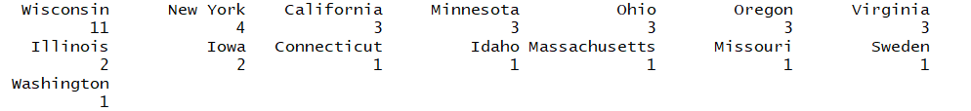

Fig. 1. Number of Decathlon All-Americans from each state.

The top three states in the Heptathlon were Wisconsin with 9, New York with 8, and California with 5 All-Americans. Both Heptathlon and Decathlon had similar results with Wisconsin, New York, and California in the top three states for both.



Fig. 2. Number of Decathlon All-Americans from each state.

The All-American dataset has a larger sample size with All-Americans that are from outside of the United States, such as England, Israel, Germany, Sweden, Bahamas, Belgium, Canada, Jamacia, Ghana, Japan, Nigeria, and Saudi Arabia. The top three states in the All-American dataset were Wisconsin with 187, Illinois 180, and New York with 109. Wisconsin and Illinois are the top states to recruit from, but there are other states that just missed the top three as you can see below in figure 3.

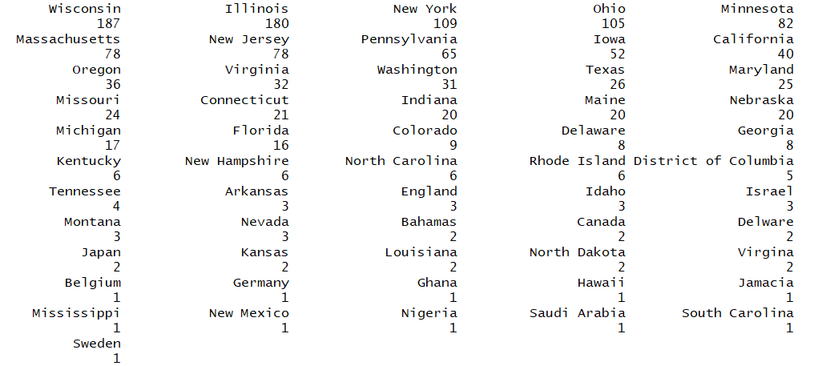

Fig. 3. Number of All-Americans from each state or country, note that two All-Americans are missing from this figure due to no information found on what state they are from.

As seen from the figures that Wisconsin is the top state to recruit from for Division III Track and Field, but Illinois was not far behind. The New England region has strong area of All-Americans, with New York, Massachusetts, New Jersey, and Pennsylvania, have sixty-five or more All-Americans in each of those states. Wisconsin and New York finished first and second in that order for both the Decathalon and Heptathlon All-Americans, although Wisconsin had a sizable amount more for the Decathalon. The strongest areas to recruit from for All-Americans in Division III Track and Field would be the western Great Lakes region; Wisconsin, Illinois, and Minnesota; also, the New England region; New York, Massachusetts, New Jersey, Pennsylvania, Maryland, and Connecticut.

## 4.3 All-Americans High School Times by Event

Finding high school times and marks may have been time consuming and challenging at times but is vital in learning what high school times and marks are considered good in college at the Division III level. This section will break down by event what the high school times and marks of the event are good based off the times and marks of the All-Americans'. The All-Americans' high school best and second best will be used, as the high school best may be an outlier to the rest of the high schooler’s performance. The breakdown of this analysis shows histograms as a visual way to see where outliers may lay and to see where an average of the All-Americans' performed in high school. There are numbers to help better understand the knowledge the histogram is showing.

## 4.3.1 Men’s 100 Meters

As seen in Figure 4 that the bulk of the 100-meter times from high school by All-Americans range from 10.6 seconds to 11.4 seconds, with a small amount faster than 10.6 seconds and a small amount of times being slower than 11.4 seconds.

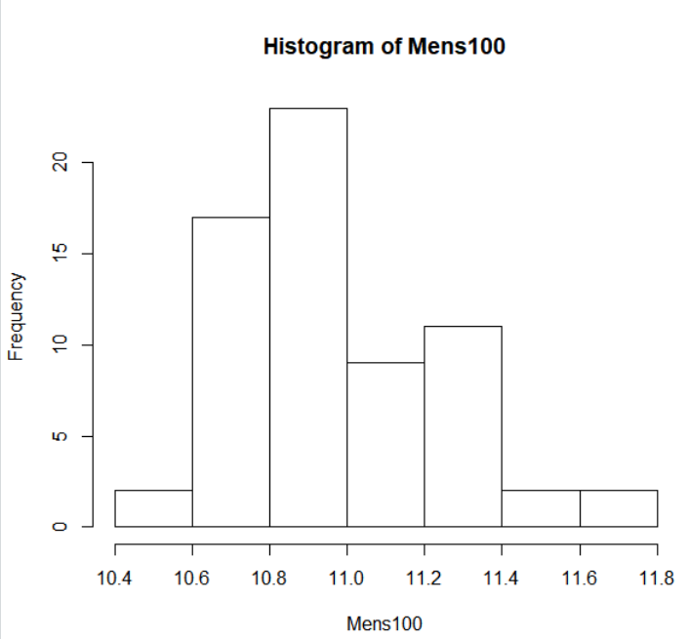

Fig. 4. Histogram of Men’s 100-meter All-Americans times from high school.

In Figure 5 the numbers tell a similar story with the first quarter starting at 10.8 seconds and the third quarter at 11.15 seconds. Meaning that the top twenty-five percent of the men’s All-American 100-meter in high school are faster or equal to 10.8 seconds and that the bottom twenty-five percent of the men’s All-American 100-meter in high school times are equal to or slower than 11.15 seconds, with the middle fifty percent of the high school times falling in between 10.8 seconds and 11.15 seconds. The average high school time of the men’s 100-meter being 10.97 seconds, and the fastest time being 10.50 seconds and the slowest being 11.76 seconds. There are twelve high school times for the men’s 100-meter that were not found, either being due to the All-American's best high school time and/or second best also not being found.



Fig. 5. Summary of Men’s 100-meter All-Americans times from high school.

## 4.3.2 Women’s 100 Meters

As seen in Figure 6 that the 100-meter times from high school by All-Americans range from 12 seconds to 13 seconds, with not many outliers.

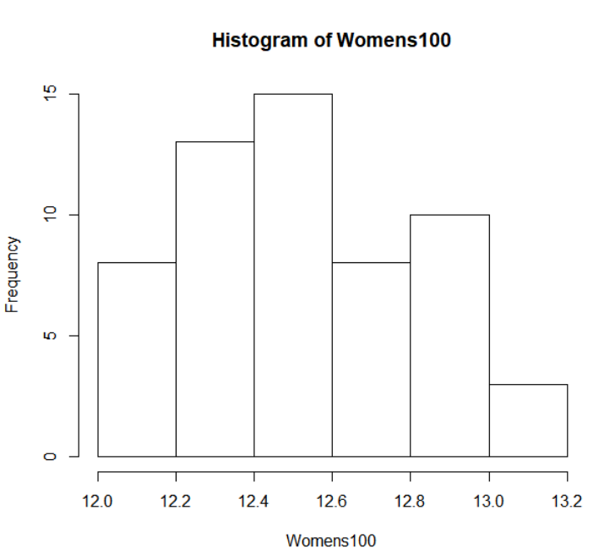

Fig. 6. Histogram of Women’s 100-meter All-Americans times from high school.

In Figure 7 the numbers tell a similar story with the first quarter starting at 12.34 seconds and the third quarter at 12.78 seconds. The average high school time of the women’s 100-meter being 12.52 seconds, and the fastest time being 12.03 seconds and the slowest being 13.17 seconds. There are twenty-three high school times for the women’s 100-meter that were not found, either being due to the All-American's best high school time and/or second best also not being found.



Fig. 7. Summary of Women’s 100-meter All-Americans times from high school.

## 4.3.3 Men’s 200 Meters

As seen in Figure 8 that the bulk of the 200-meter times from high school by All-Americans range from 21.5 seconds to 23.5 seconds, with a small group being faster than 21.5 seconds.

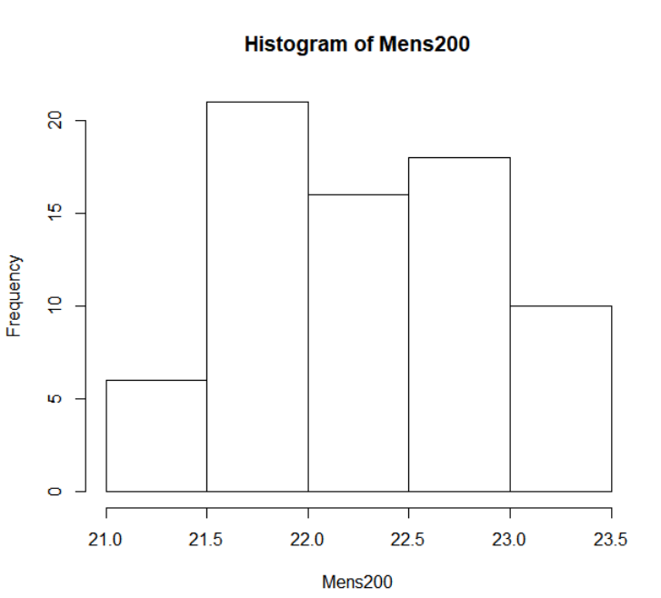

Fig. 8. Histogram of Men’s 200-meter All-Americans times from high school.

In Figure 9 the numbers tell a slightly different story with the first quarter starting at 21.86 seconds and the third quarter at 22.73 seconds. The average high school time of the men’s 200-meter being 22.27 seconds, and the fastest time being 21.2 seconds and the slowest being 23.47 seconds. There are nine high school times for the men’s 200-meter that were not found, either being due to the All-American's best high school time and/or second best also not being found.



Fig. 9. Summary of Men’s 200-meter All-Americans times from high school.

## 4.3.4 Women’s 200 Meters

As seen in Figure 10 that the bulk of the 200-meter times from high school by All-Americans range from 25 seconds to 26 seconds, with many outliers slower than 26 seconds and a small amount faster than 25 seconds.

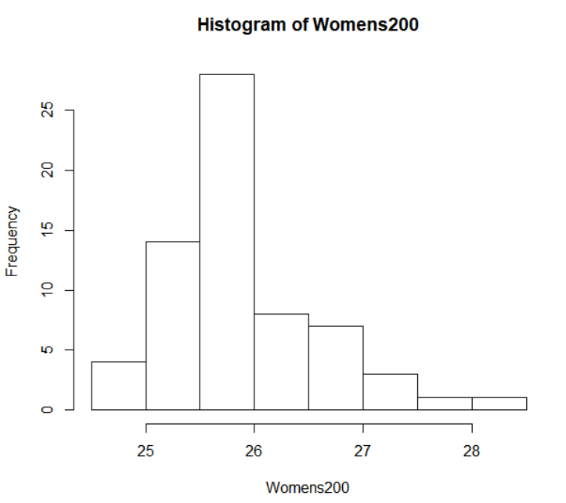

Fig. 10. Histogram of Women’s 200-meter All-Americans times from high school.

In Figure 11 the numbers tell a similar story with the first quarter starting at 25.46 seconds and the third quarter at 26.18 seconds. The average high school time of the women’s 200-meter being 25.92 seconds, and the fastest time being 24.84 seconds and the slowest being 28.40 seconds. There are fourteen high school times for the women’s 200-meter that were not found, either being due to the All-American's best high school time and/or second best also not being found.



Fig. 11. Summary of Women’s 200-meter All-Americans times from high school.

## 4.3.5 Men’s 400 Meters

As seen in Figure 12 that the bulk of the 400-meter times from high school by All-Americans range from 48 seconds to 51 seconds, with a small group being faster than 48 seconds and different small groups slower than 51 seconds.

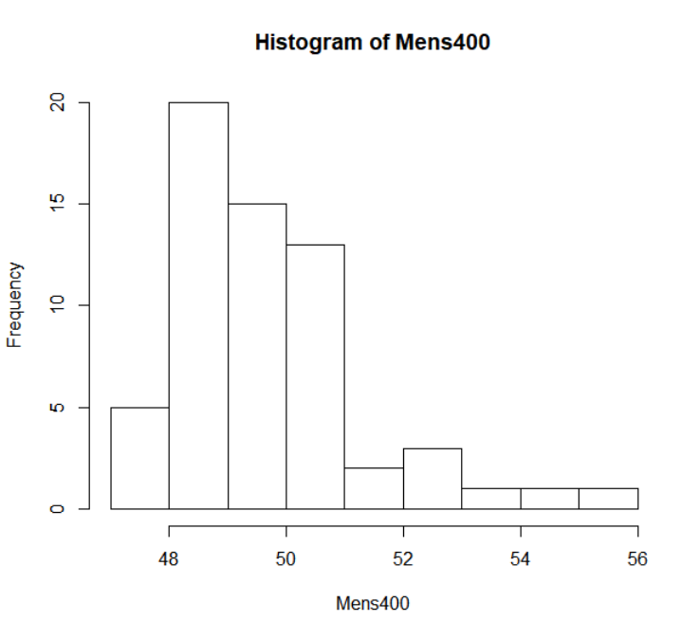

Fig. 12. Histogram of Men’s 400-meter All-Americans times from high school.

In Figure 13 the numbers tell a similar story with the first quarter starting at 48.23 seconds and the third quarter at 50.08 seconds. The average high school time of the men’s 400-meter being 49.58 seconds, and the fastest time being 47.53 seconds and the slowest being 55.14 seconds. There are nineteen high school times for the men’s 400-meter that were not found, either being due to the All-American's best high school time and/or second best also not being found.



Fig. 13. Summary of Men’s 400-meter All-Americans times from high school.

## 4.3.6 Women’s 400 Meters

As seen in Figure 14 that the bulk of the 400-meter times from high school by All-Americans range from 56 seconds to 59 seconds, with many outliers slower than 59 seconds and a small amount faster than 56 seconds.

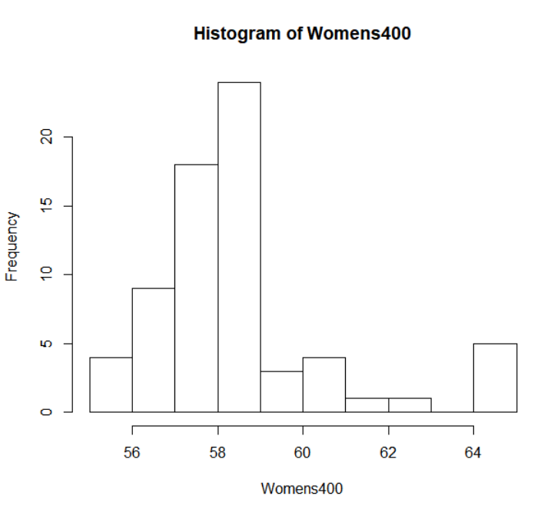

Fig. 14. Histogram of Women’s 400-meter All-Americans times from high school.

In Figure 15 the numbers tell a similar story with the first quarter starting at 57.32 seconds and the third quarter at 58.88 seconds. The average high school time of the women’s 400-meter being 58.47, and the fastest time being 55.6 seconds and the slowest being 64.8 seconds or 1:04.8 minutes. There are eleven high school times for the women’s 400-meter that were not found, either being due to the All-American's best high school time and/or second best also not being found.



Fig. 15. Summary of Women’s 400-meter All-Americans times from high school.

## 4.3.7 Men’s 800 Meters

As seen in Figure 16 that the bulk of the 800-meter times from high school by All-Americans range from 110 seconds to 125 seconds, with different small groups slower than 125 seconds.

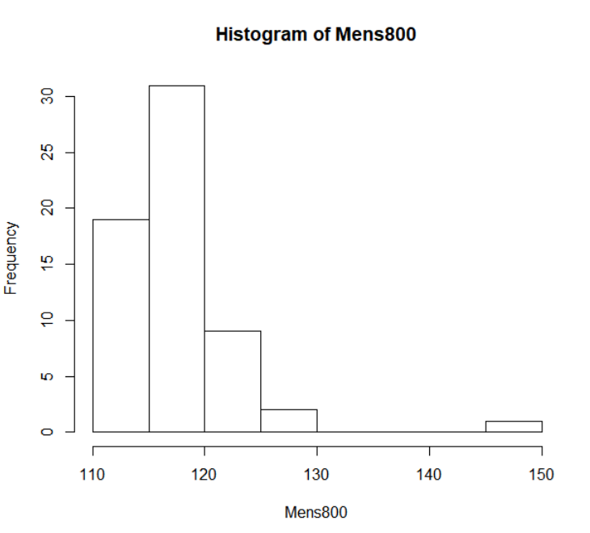

Fig. 16. Histogram of Men’s 800-meter All-Americans times from high school.

In Figure 17 the numbers tell a similar story with the first quarter starting at 1:54.8 minutes, and the third quarter at 1:59.1 minutes. The average high school time of the men’s 800-meter being 1:57.6 minutes, and the fastest time being 1:51.9 minutes and the slowest being 2:25.9 minutes. There are eighteen high school times for the men’s 800-meter that were not found, either being due to the All-American's best high school time and/or second best also not being found.



Fig. 17. Summary of Men’s 800-meter All-Americans times from high school.

## 4.3.8 Women’s 800 Meters

As seen in Figure 18 that most of the 800-meter times from high school by All-Americans range from 135 seconds to 140 seconds, and small amounts slower and faster than that range.

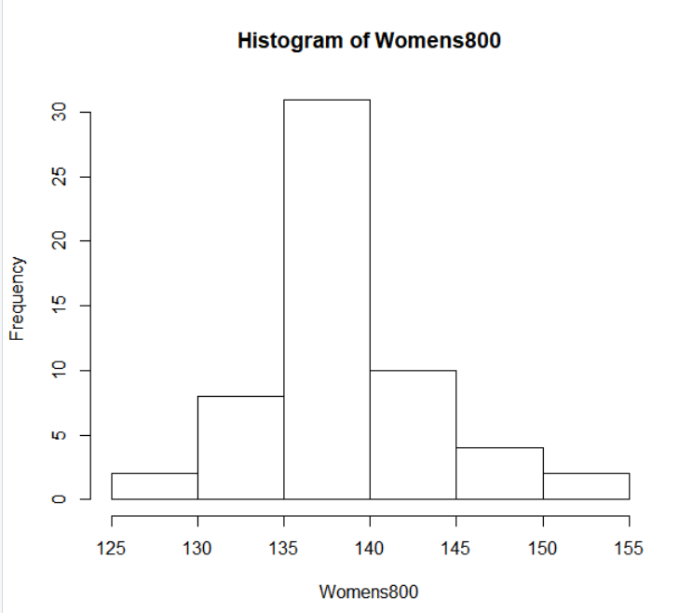

Fig. 18. Histogram of Women’s 800-meter All-Americans times from high school.

In Figure 19 the numbers tell a similar story with the first quarter starting at 2:15.9 minutes and the third quarter at 2:20.4 minutes. The average high school time of the women’s 800-meter being 2:19 minutes, and the fastest time being 2:09.7 minutes and the slowest being 2:34.5. There are twenty-three high school times for the women’s 800-meter that were not found, either being due to the All-American's best high school time and/or second best also not being found.



Fig. 19. Summary of Women’s 800-meter All-Americans times from high school.

## 4.3.9 Men’s 1,500 Meters

As seen in Figure 20 that the bulk of the 1,600-meter times from high school by All-Americans range from 255 seconds to 265 seconds, with different small groups slower than 265 seconds. The high school times have all been converted to 1,600-meter, as the 1,600-meter is the common comparison to the 1,500-meter in college.

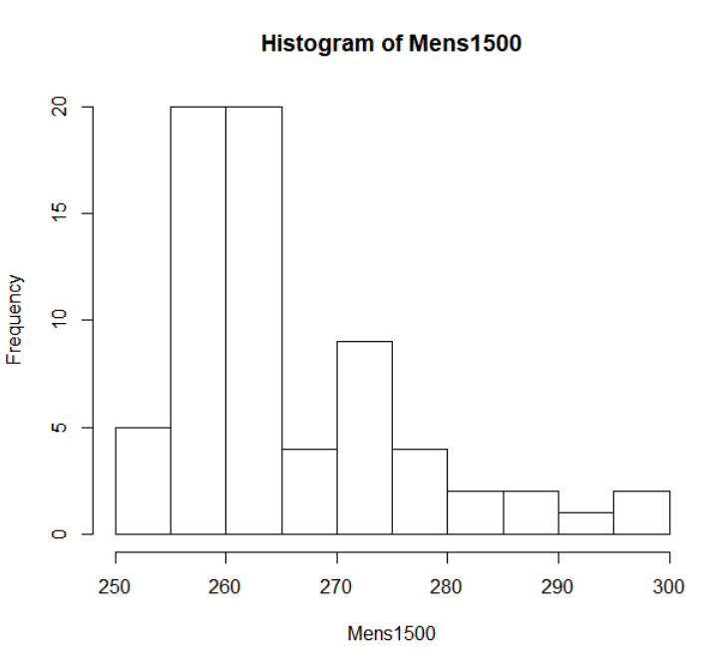

Fig. 20. Histogram of Men’s 1,600-meter All-Americans times from high school.

In Figure 21 the numbers tell a similar story with the first quarter starting at 4:18.8 minutes, and the third quarter at 4:31.8 minutes. The average high school time of the men’s 1,600-meter being 4:25.7 minutes, and the fastest time being 4:12 minutes and the slowest being 4:58.4 minutes. There are eleven high school times for the men’s 1,600-meter that were not found, either being due to the All-American's best high school time and/or second best also not being found.



Fig. 21. Summary of Men’s 1,600-meter All-Americans times from high school.

## 4.3.10 Women’s 1,500 Meters

As seen in Figure 22 that there is a spike of the 1,600-meter times from high school by All-Americans 300 seconds to 310 seconds, with different small groups slower than 310 seconds and about a hand full of high schoolers faster than 300 seconds. The high school times have all been converted to 1,600-meter, as the 1,600-meter is the common comparison to the 1,500-meter in college.

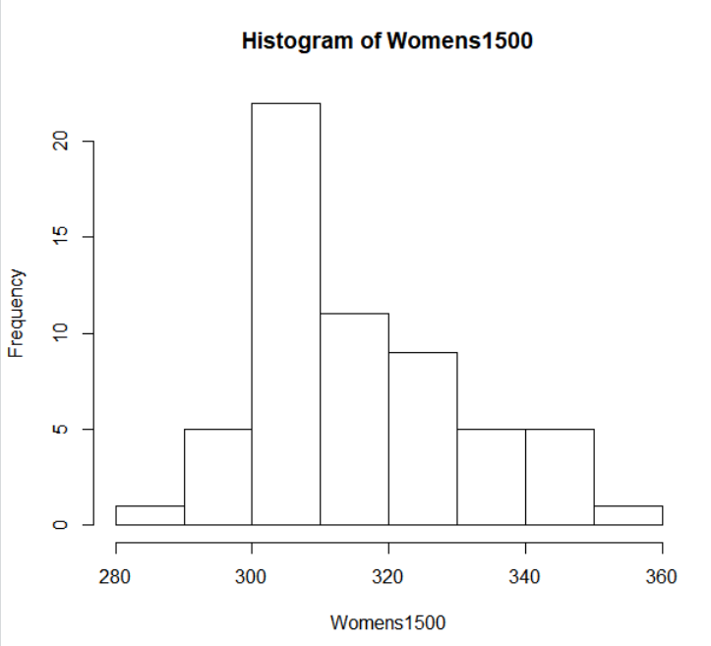

Fig. 22. Histogram of Women’s 1,600-meter All-Americans times from high school.

In Figure 23 the numbers tell a likely story with the first quarter starting at 5:04 minutes and the third quarter at 5:25.2 minutes. The average high school time of the women’s 1,600-meter being 5:15.8 minutes, and the fastest time being 4:47.6 minutes and the slowest being 5:58.1. There are twenty-one high school times for the women’s 1,600-meter that were not found, either being due to the All-American's best high school time and/or second best also not being found.



Fig. 23. Summary of Women’s 1,600-meter All-Americans times from high school.

## 4.3.11 Men’s 5,000 Meters

As seen in Figure 24 that the bulk of the 3,200-meter times from high school by All-Americans range from 540 seconds to 580 seconds, with different small groups slower than 265 seconds. The high school times have all been converted to 3,200-meter, as the 3,200-meter is the common comparison to the 5,000-meter in college.

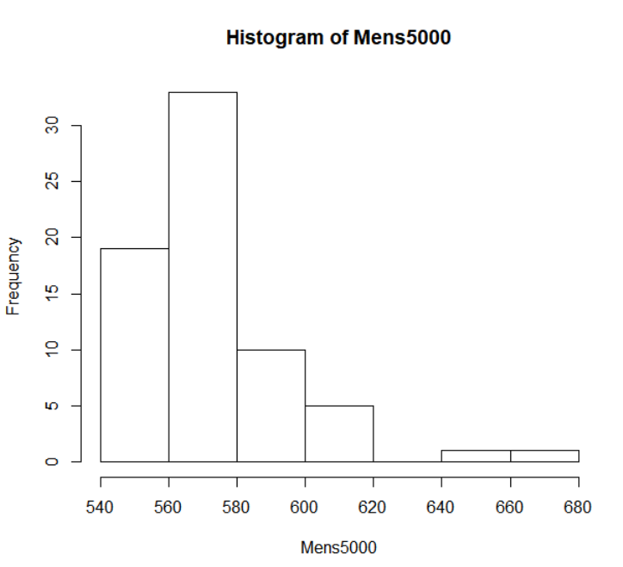

Fig. 24. Histogram of Men’s 5,000-meter All-Americans, 3,200-meter times from high school.

In Figure 25 the numbers tell a similar story with the first quarter starting at 9:18.5 minutes, and the third quarter at 9:39.7 minutes. The average high school time of the men’s 3,200-meter being 9:31.7 minutes, and the fastest time being 9:07.1 minutes and the slowest being 11:00.4 minutes. There are eleven high school times for the men’s 3,200-meter that were not found, either being due to the All-American's best high school time and/or second best also not being found.



Fig. 25. Summary of Men’s 5,000-meter All-Americans, 3,200-meter times from high school.

## 4.3.12 Women’s 5,000 Meters

As seen in Figure 26 there is a wide variety of the 3,200-meter times from high school by All-Americans from 640 seconds to 760 seconds, with one time faster than the rest. The high school times have all been converted to 3,200-meter, as the 3,200-meter is the common comparison to the 5,000-meter in college.

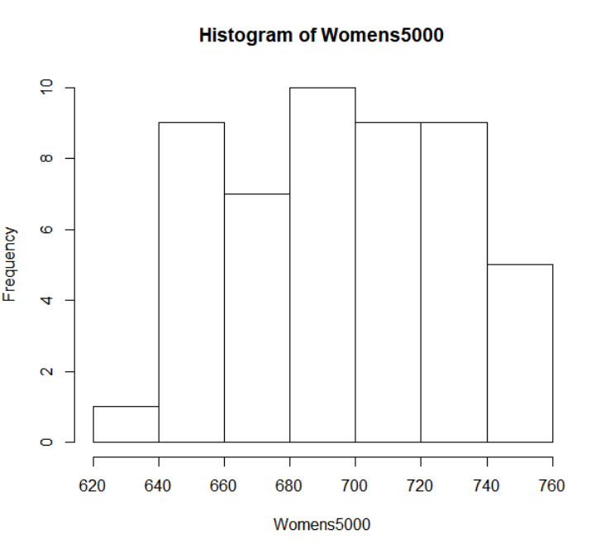

Fig. 26. Histogram of Women’s 5,000-meter All-Americans, 3,200-meter times from high school.

In Figure 27 the numbers tell a likely story with the first quarter starting at 11:08.5 minutes and the third quarter at 12:08.8.2 minutes. The average high school time of the women’s 3,200-meter being 11:36.2 minutes, and the fastest time being 10:28.3 minutes and the slowest being 12:37.4. There are thirty high school times for the women’s 3,200-meter that were not found, either being due to the All-American's best high school time and/or second best also not being found.



Fig. 27. Summary of Women’s 5,000-meter All-Americans, 3,200-meter times from high school.

## 4.3.13 Men’s 10,000 Meters

As seen in Figure 28 many of the 3,200-meter times from high school by All-Americans range from 560 seconds to 580 seconds, with different small groups slower than 580 seconds. The high school times have all been converted to 3,200-meter, as the 3,200-meter is the common comparison to the 10,000-meter in college.

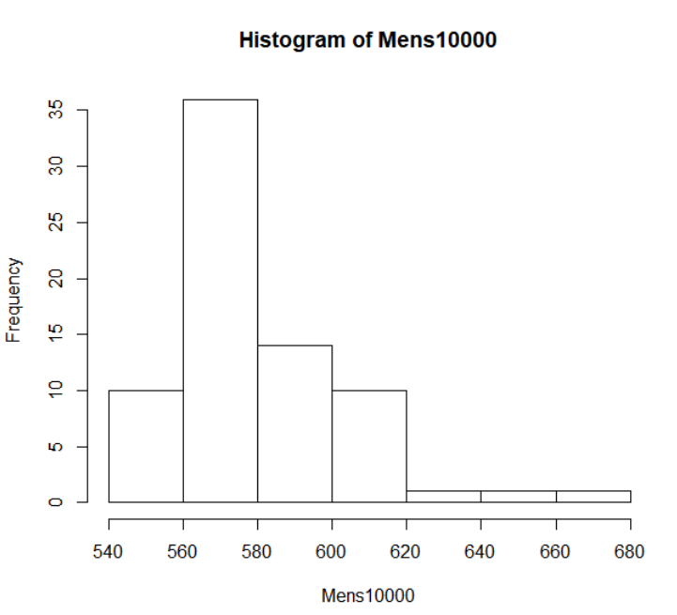

Fig. 28. Histogram of Men’s 10,000-meter All-Americans, 3,200-meter times from high school.

In Figure 29 the numbers tell a similar story with the first quarter starting at 9:22 minutes, and the third quarter at 9:45.5 minutes. The average high school time of the men’s 3,200-meter being 9:38.5 minutes, and the fastest time being 9:07.6 minutes and the slowest being 11:00.4 minutes. There are seven high school times for the men’s 3200-meter that were not found, either being due to the All-American's best high school time and/or second best also not being found.



Fig. 29. Summary of Men’s 10,000-meter All-Americans, 3,200-meter times from high school.

## 4.3.14 Women’s 10,000 Meters

As seen in Figure 30 there is a wide variety of the 3,200-meter times from high school by All-Americans looking like a bell curve, with one time slower than the rest. The high school times have all been converted to 3,200-meter, as the 3,200-meter is the common comparison to the 10,000-meter in college.

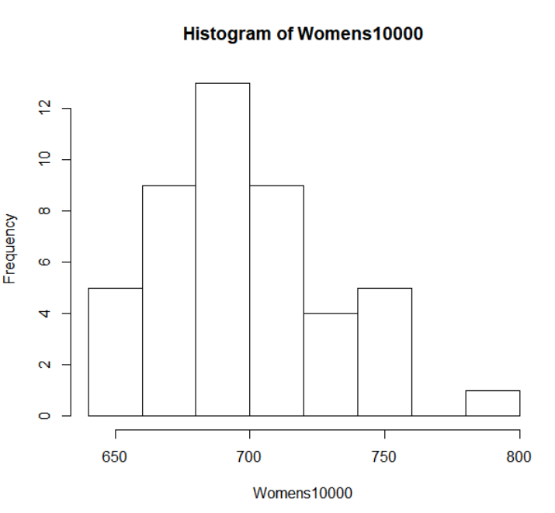

Fig. 30. Histogram of Women’s 10,000-meter All-Americans, 3,200-meter times from high school.

In Figure 31 the numbers tell a likely story with the first quarter starting at 11:14.6 minutes and the third quarter at 11:54.4 minutes. The average high school time of the women’s 3,200-meter being 11:37.3 minutes, and the fastest time being 10:40.0 minutes and the slowest being 13:06.8 minutes. There are thirty-four high school times for the women’s 3,200-meter that were not found, either being due to the All-American's best high school time and/or second best also not being found.



Fig. 31. Summary of Women’s 10,000-meter All-Americans, 3,200-meter times from high school.

## 4.3.15 Men’s 110 Meter Hurdles

As seen in Figure 32 many of the 110-meter hurdles times from high school by All-Americans range from 14 seconds to 16 seconds, with a couple times slower than 16 seconds.

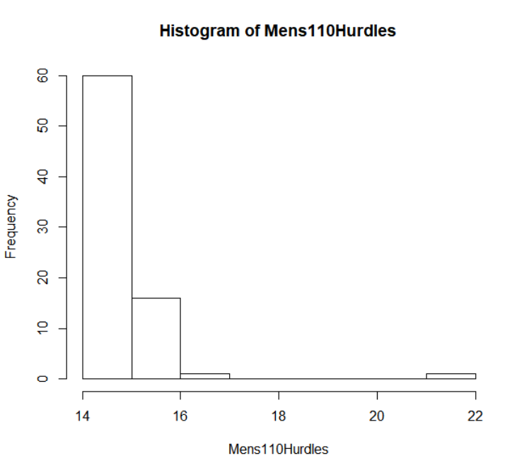

Fig. 32. Histogram of Men’s 110-meter hurdles All-Americans times from high school.

In Figure 33 the numbers tell a similar story with the first quarter starting at 14.51 seconds, and the third quarter at 14.95 seconds. The average high school time of the men’s 110-meter hurdles being 14.87 seconds, and the fastest time being 14.23 seconds and the slowest being 21.28 seconds. There are two high school times for the men’s 110-meter hurdles that were not found, either being due to the All-American's best high school time and/or second best also not being found.



Fig. 33. Summary of Men’s 110-meter hurdles All-Americans times from high school.

## 4.3.16 Women’s 100 Meter Hurdles

As seen in Figure 34 there is many of the 100-meter hurdles times from high school by All-Americans from 14.5 seconds to 16 seconds, with one time faster than the rest and smaller amounts slower than 16 seconds.

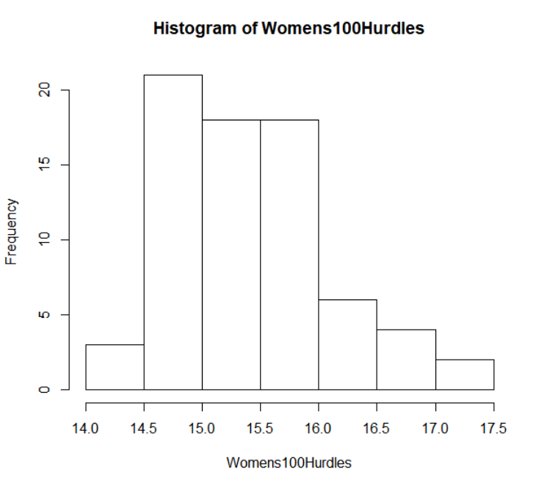

Fig. 34. Histogram of Women’s 100-meter hurdles All-Americans times from high school.

In Figure 35 the numbers tell a likely story with the first quarter starting at 14.91 seconds and the third quarter at 15.78 seconds. The average high school time of the women’s 100-meter hurdles being 15.42 seconds, and the fastest time being 14.42 seconds and the slowest being 17.40 seconds. There are eight high school times for the women’s 3,200-meter that were not found, either being due to the All-American's best high school time and/or second best also not being found.



Fig. 35. Summary of Women’s 100-meter hurdles All-Americans times from high school.

## 4.3.17 Men’s 400 Meter Hurdles

As seen in Figure 36 many of the 300-meter hurdles times from high school by All-Americans range from 38 seconds to 44 seconds, with a couple times slower than 44 seconds and a small group faster than 38 seconds. The high school times have all been converted to 300-meter hurdles, as the 300-meter hurdles is the common comparison to the 400-meter hurdles in college.

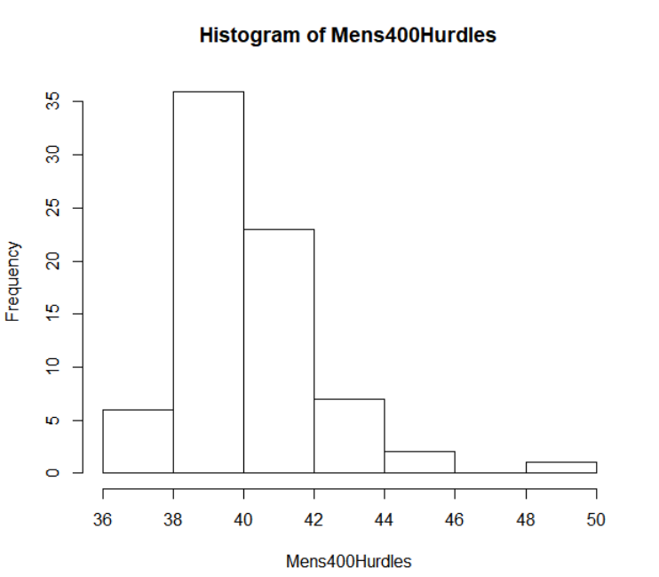

Fig. 36. Histogram of Men’s 400-meter hurdles All-Americans, 300-meter hurdle times from high school.

In Figure 37 the numbers tell a similar story with the first quarter starting at 38.94 seconds, and the third quarter at 41.19 seconds. The average high school time of the men’s 300-meter hurdles being 40.15 seconds, and the fastest time being 37.73 seconds and the slowest being 49.70 seconds. There are five high school times for the men’s 400-meter hurdles that were not found, either being due to the All-American's best high school time and/or second best also not being found.



Fig. 37. Summary of Men’s 400-meter hurdles All-Americans, 300-meter hurdle times from high school.

## 4.3.18 Women’s 400 Meter Hurdles

As seen in Figure 38 there is a big variety of the 300-meter hurdles times from high school by All-Americans with the most from 46 seconds to 47 seconds. The high school times have all been converted to 300-meter hurdles, as the 300-meter hurdles is the common comparison to the 400-meter hurdles in college.

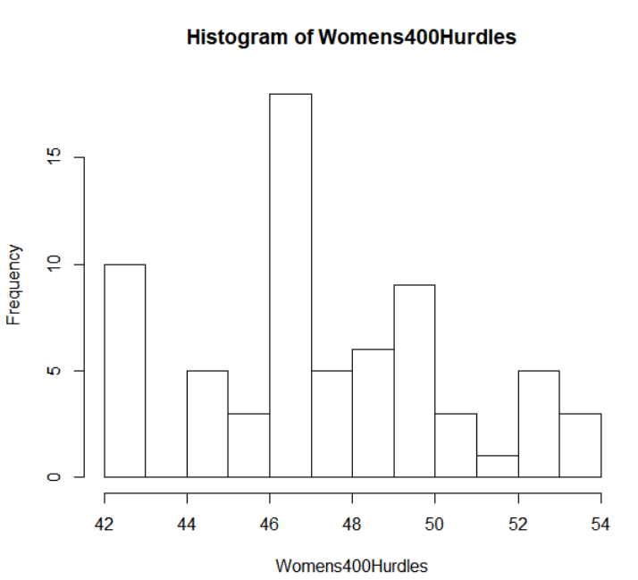

Fig. 38. Histogram of Women’s 400-meter hurdles All-Americans, 300-meter hurdles times from high school.

In Figure 39 the numbers tell a likely story with the first quarter starting at 45.74 seconds and the third quarter at 49.65 seconds. The average high school time of the women’s 300-meter hurdles being 47.36 seconds, and the fastest time being 42.54 seconds and the slowest being 53.20 seconds. There are twelve high school times for the women’s 400-meter hurdles that were not found, either being due to the All-American's best high school time and/or second best also not being found.



Fig. 39. Summary of Women’s 400-meter hurdles All-Americans, 300-meter hurdle times from high school.

## 4.3.19 Men’s 3,000 Meter Steeplechase

As seen in Figure 40 many of the 3,200-meter times from high school by All-Americans range from 500 seconds to 610 seconds, with a couple times faster than 500 seconds and small groups slower than 610 seconds. The high school times have all been converted to 3,200-meter, as the 3,200-meter is the common comparison to the 3,000-meter Steeplechase in college.

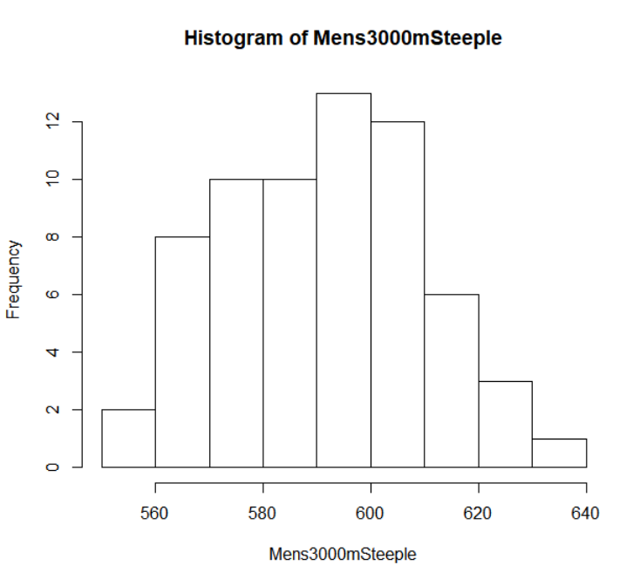

Fig. 40. Histogram of Men’s 3,000-meter steeplechase All-Americans, 3,200-meter times from high school.

In Figure 41 the numbers tell a similar story with the first quarter starting at 9:33.1 minutes, and the third quarter at 10:01.8 minutes. The average high school time of the men’s 3,200-meter being 9:50.6 minutes, and the fastest time being 9:15.7 minutes and the slowest being 10:34.9 minutes. There are fifteen high school times for the men’s 3,200-meter that were not found, either being due to the All-American's best high school time and/or second best also not being found.



Fig. 41. Summary of Men’s 3,000-meter steeplechase All-Americans, 3,000-meter times from high school.

## 4.3.20 Women’s 3,000 Meter Steeplechase

As seen in Figure 42 there is a big variety of the 3,200-meter times from high school by All-Americans with the most from 650 seconds to 725 seconds. The high school times have all been converted to 3,200-meter, as the 3,200-meter is the common comparison to the 3,300-meter steeplechase in college.

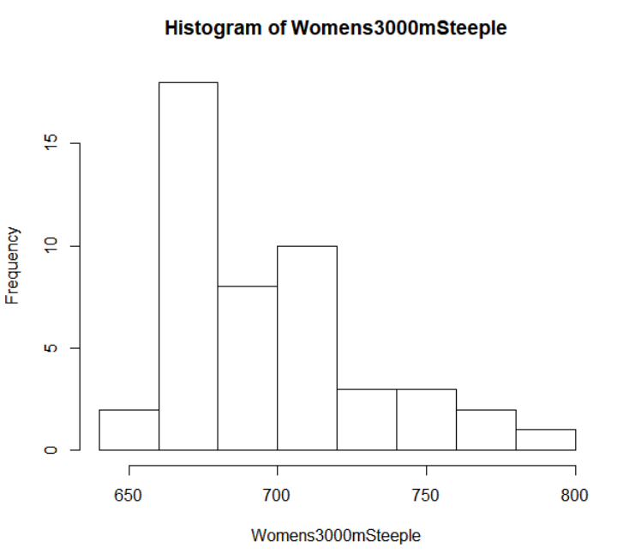

Fig. 42. Histogram of Women’s 3,000-meter steeplechase All-Americans, 3,200-meter times from high school.

In Figure 43 the numbers tell a likely story with the first quarter starting at 11:14.0 minutes and the third quarter at 11:51.5 minutes. The average high school time of the women’s 3,200-meter being 11:37.2 minutes, and the fastest time being 10:56.4 minutes and the slowest being 13:13.0 minutes. There are thirty-three high school times for the women’s 3,200-meter that were not found, either being due to the All-American's best high school time and/or second best also not being found.



Fig. 43. Summary of Women’s 3,000-meter steeplechase All-Americans, 3,200-meter times from high school.

## 4.3.21 Men’s High Jump

As seen in Figure 44 many of the high jump marks from high school by All-Americans range from 1.9 meters to 2 meters, with different groups higher and lower than the above range.

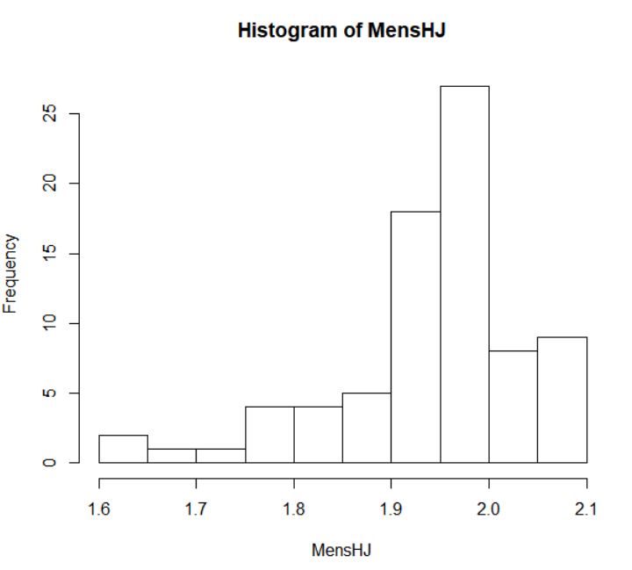

Fig. 44. Histogram of Men’s High Jump All-Americans marks from high school.

In Figure 45 the numbers tell a similar story with the first quarter starting at 1.905 meters or 6’3”, and the third quarter at 1.981 meters or 6’6”. The average high school mark of the men’s high jump being 1.937 meters or 6’4.25”, and the highest mark being 2.089 meters or 6’10.25” and the lowest being 1.625 meters or 5’4”. There are seven high school marks for the men’s high jump that were not found, either being due to the All-American's best high school time and/or second best also not being found.



Fig. 45. Summary of Men’s high jump All-Americans marks from high school.

## 4.3.22 Women’s High Jump

As seen in Figure 46 there is a big variety of high jump marks from high school by All-Americans the biggest group is around 1.65 meters.

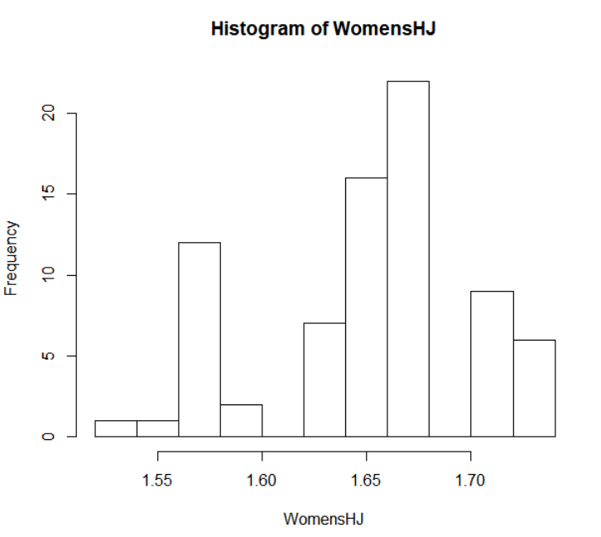

Fig. 46. Histogram of Women’s high jump All-Americans marks from high school.

In Figure 47 the numbers tell an interesting story with the first quarter starting at 1.625 meters or 5’4” and the third quarter at 1.676 meters or 5’6”. The average high school mark of the women’s high jump being 1.651 or 5’5”, and the highest mark being 1.727 meters or 5’8” and the lowest being 1.524 meters or 5’0”. There are eight high school marks for the women’s high jump that were not found, either being due to the All-American's best high school time and/or second best also not being found.



Fig. 47. Summary of Women’s high jump All-Americans marks from high school.

## 4.3.23 Men’s Long Jump

As seen in Figure 48 bulk of the long jump marks from high school by All-Americans range from 6.5 meters and above, with different groups lower than 6.5 meters.

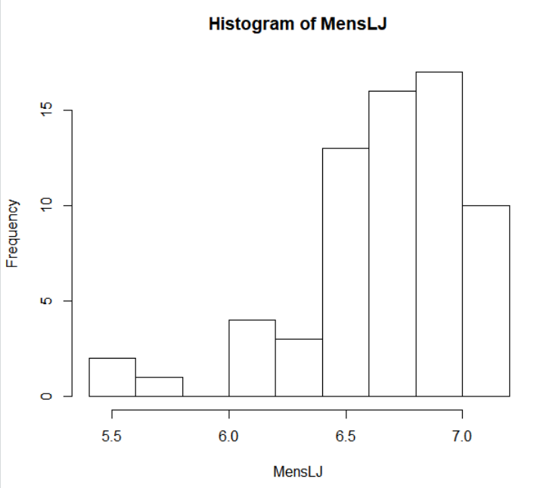

Fig. 48. Histogram of Men’s Long Jump All-Americans marks from high school.

In Figure 49 the numbers tell a similar story with the first quarter starting at 6.480 meters or 21’3”, and the third quarter at 6.946 meters or 22’9.5”. The average high school mark of the men’s long jump being 6.669 meters or 21’10.5”, and the farthest mark being 7.131 meters or 23’4.75” and the shortest being 5.454 meters or 17’10.75”. There are fourteen high school marks for the men’s high jump that were not found, either being due to the All-American's best high school time and/or second best also not being found.



Fig. 49. Summary of Men’s long jump All-Americans marks from high school.

## 4.3.24 Women’s Long Jump

As seen in Figure 50 there is an interesting look at the long jump marks from high school by All-Americans and there is an increase of number of marks as the height increases, but slowly drops off around 5.5 meters.

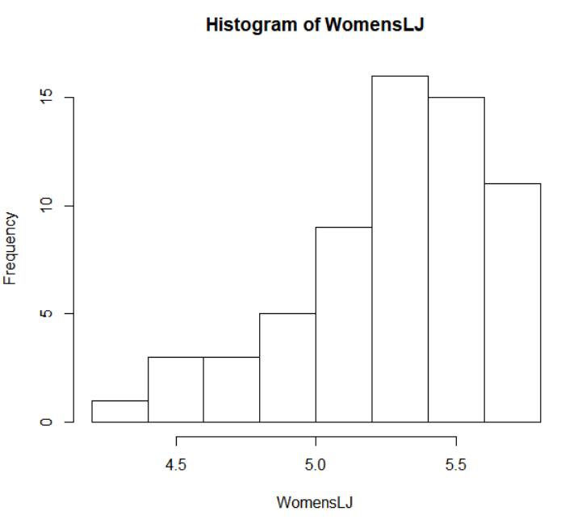

Fig. 50. Histogram of Women’s long jump All-Americans marks from high school.

In Figure 51 the numbers tell an interesting story with the first quarter starting at 5.098 meters or 16’8.75” and the third quarter at 5.498 meters or 18’0.5”. The average high school mark of the women’s long jump being 5.280 or 17’3.75”, and the farthest mark being 5.727 meters or 18’9.5” and the shortest being 4.394 meters or 14’5”. There are seventeen high school marks for the women’s long jump that were not found, either being due to the All-American's best high school time and/or second best also not being found.



Fig. 51. Summary of Women’s long jump All-Americans marks from high school.

## 4.3.25 Men’s Pole Vault

As seen in Figure 52 there is spike of the pole vault marks from high school by All-Americans around 4.5 meters, with different groups higher and lower than 4.5 meters.

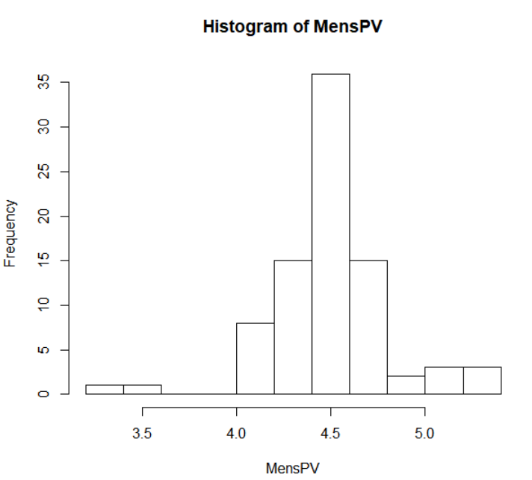

Fig. 52. Histogram of Men’s Pole Vault All-Americans marks from high school.

In Figure 53 the numbers tell a similar story with the first quarter starting at 4.343 meters or 14’3”, and the third quarter at 4.648 meters or 15’3”. The average high school mark of the men’s pole vault being 4.487 meters or 14’8.5”, and the highest mark being 5.260 meters or 17’3” and the lowest being 3.352 meters or 11’0”.



Fig. 53. Summary of Men’s pole vault All-Americans marks from high school.

## 4.3.26 Women’s Pole Vault

As seen in Figure 54 there is an interesting look at the pole vault marks from high school by All-Americans with up and down amount as the height increases but has big spikes from 3.3 meters to 3.7 meters.

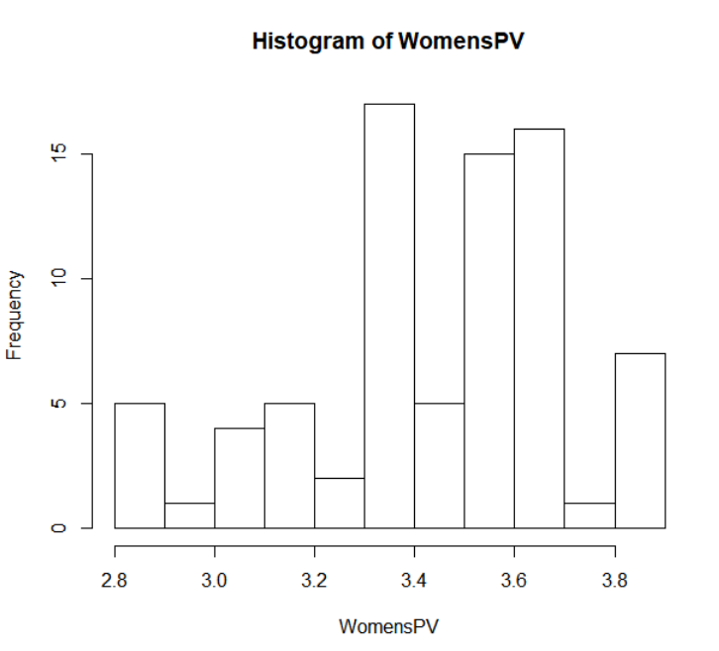

Fig. 54. Histogram of Women’s pole vault All-Americans marks from high school.

In Figure 55 the numbers have a big spread with the first quarter starting at 3.352 meters or 11’0” and the third quarter at 3.651 meters or 11’11.75”. The average high school mark of the women’s pole vault being 3.444 or 11’3.5”, and the highest mark being 3.863 meters or 12’8” and the lowest being 2.895 meters or 9’6”. There are eight high school marks for the women’s pole vault that were not found, either being due to the All-American's best high school time and/or second best also not being found.



Fig. 55. Summary of Women’s pole vault All-Americans marks from high school.

## 4.3.27 Men’s Triple Jump

As seen in Figure 56 the triple jump marks from high school by All-Americans there is a bell shape like curve, with the curve ending differently than it started.

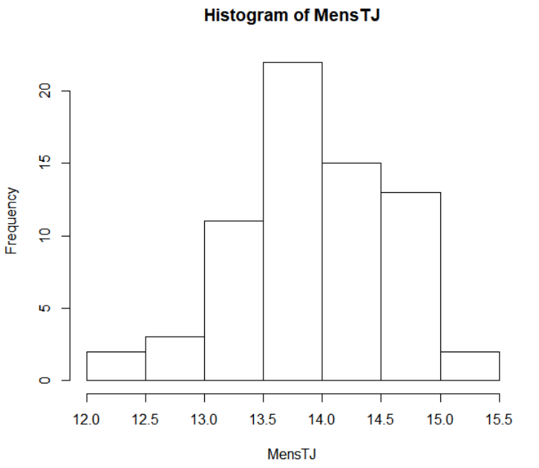

Fig. 56. Histogram of Men’s Pole Vault All-Americans marks from high school.

In Figure 57 the numbers tell a similar story with the first quarter starting at 13.51 meters or 44’4”, and the third quarter at 14.39 meters or 47’2.5”. The average high school mark of the men’s triple jump being 13.87 meters or 45’6”, and the farthest mark being 15.16 meters or 49’9” and the shortest being 12.03 meters or 39’5.5”. There are twelve high school marks for the men’s triple jump that were not found, either being due to the All-American's best high school time and/or second best also not being found



Fig. 57. Summary of Men’s triple jump All-Americans marks from high school.

## 4.3.28 Women’s Triple Jump

As seen in Figure 58 most of the triple jump marks from high school by All-Americans range from 10.5 meters to 12.0 meters, with small amount outside of that range.

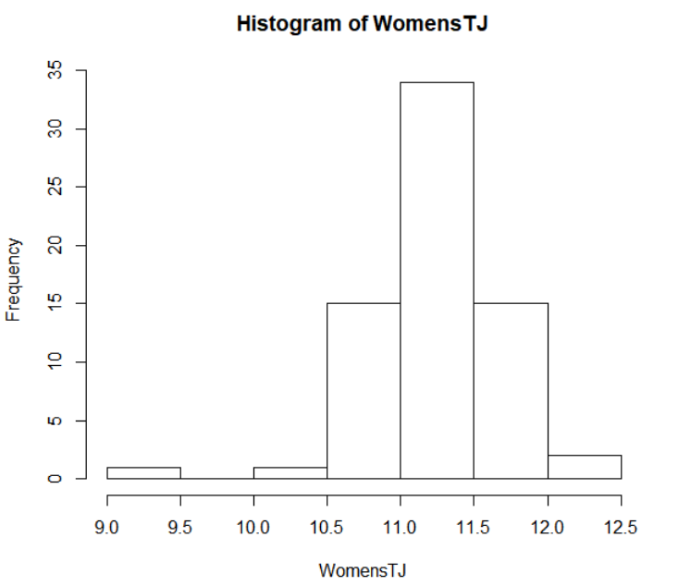

Fig. 58. Histogram of Women’s triple jump All-Americans marks from high school.

In Figure 59 the numbers are grouped closely together with the first quarter starting at 11.028 meters or 36’2” and the third quarter at 11.493 meters or 37’8.5”. The average high school mark of the women’s triple jump being 11.246 or 36’10.75”, and the farthest mark being 12.020 meters or 39’5.25” and the shortest being 9.499 meters or 31’2”. There are twelve high school marks for the women’s triple jump that were not found, either being due to the All-American's best high school time and/or second best also not being found.



Fig. 59. Summary of Women’s triple jump All-Americans marks from high school.

## 4.3.29 Men’s Shot Put

As seen in Figure 60 the triple jump marks from high school by All-Americans there is a gradual increase as the distance increases, but the amount drops after 18 meters.

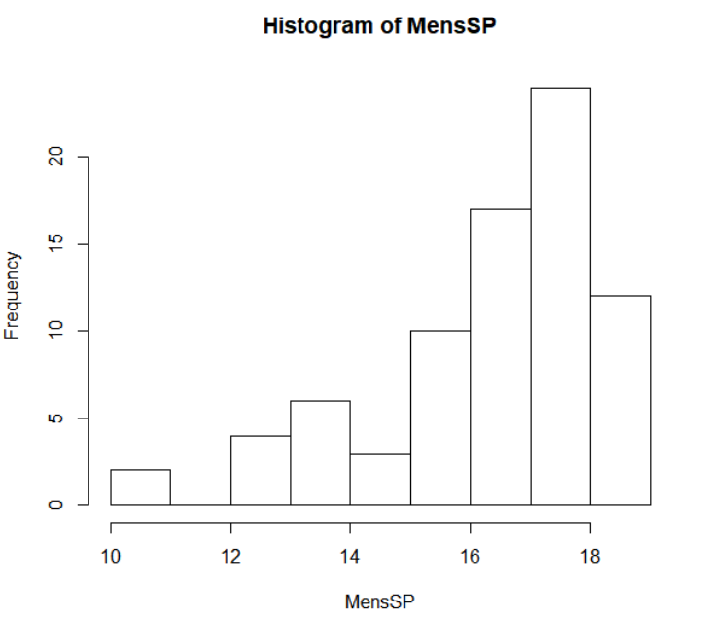

Fig. 60. Histogram of Men’s Shot Put All-Americans marks from high school.

In Figure 61 the numbers tell a similar story with the first quarter starting at 15.67 meters or 51’5”, and the third quarter at 17.65 meters or 57’11”. The average high school mark of the men’s shot put being 17.65 meters or 53’7.25”, and the farthest mark being 18.52 meters or 60’9” and the shortest being 10.95 meters or 35’11”. There are two high school marks for the men’s shot put that were not found, either being due to the All-American's best high school time and/or second best also not being found



Fig. 61. Summary of Men’s shot put All-Americans marks from high school.

## 4.3.30 Women’s Shot Put

As seen in Figure 62 the triple jump marks from high school by All-Americans is like a bell curve with slightly bigger curve above 12.5 meters.

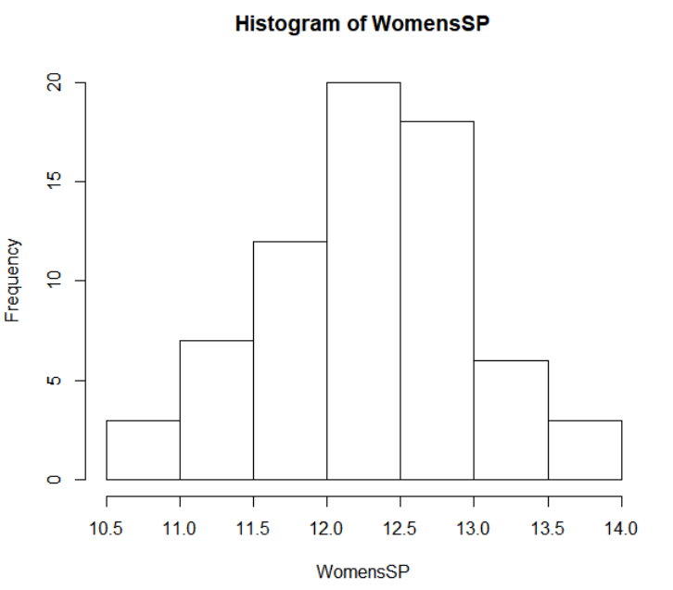

Fig. 62. Histogram of Women’s shot put All-Americans marks from high school.

In Figure 63 the numbers tell a similar story with the first quarter starting at 11.84 meters or 38’10” and the third quarter at 12.74 meters or 41’9.5”. The average high school mark of the women’s shot put being 12.27 or 40’3”, and the farthest mark being 13.63 meters or 44’8.5” and the shortest being 10.53 meters or 34’6.5”. There are eleven high school marks for the women’s shot put that were not found, either being due to the All-American's best high school time and/or second best also not being found.



Fig. 63. Summary of Women’s shot put All-Americans marks from high school.

## 4.3.31 Men’s Discus

As seen in Figure 64 the discus marks from high school by All-Americans there is many of the marks from 40 meters to 55 meters, with small amounts above and below the range.

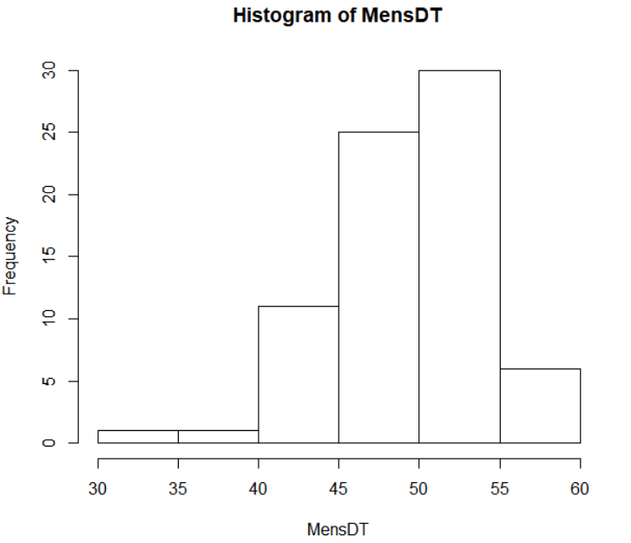

Fig. 64. Histogram of Men’s Discus All-Americans marks from high school.

In Figure 65 the numbers tell a similar story with the first quarter starting at 46.14 meters or 151’4.5”, and the third quarter at 52.57 meters or 172’5.5”. The average high school mark of the men’s discus being 49.34 meters or 161’10.5”, and the farthest mark being 59.87 meters or 196’5” and the shortest being 30.18 meters or 99’0”. There are six high school marks for the men’s discus that were not found, either being due to the All-American's best high school time and/or second best also not being found



Fig. 65. Summary of Men’s discus All-Americans marks from high school.

## 4.3.32 Women’s Discus

As seen in Figure 66 the discus marks from high school by All-Americans spike from 36 meters to 42 meters, with small groups lower and higher than this range.

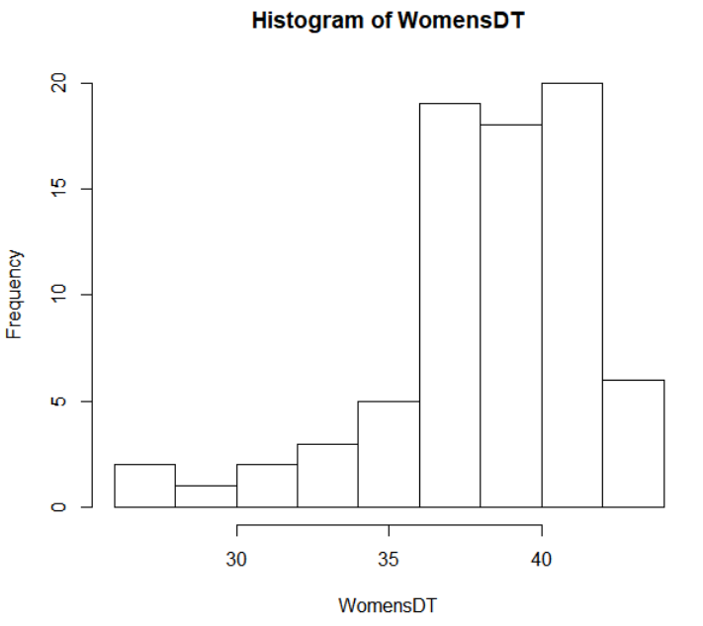

Fig. 66. Histogram of Women’s discus All-Americans marks from high school.

In Figure 67 the numbers tell a similar story with the first quarter starting at 36.99 meters or 121’4.25” and the third quarter at 40.66 meters or 133’4.75”. The average high school mark of the women’s discus being 38.22 or 125’4.75”, and the farthest mark being 43.28 meters or 142’0” and the shortest being 26.73 meters or 87’8.25”. There are four high school marks for the women’s discus that were not found, either being due to the All-American's best high school time and/or second best also not being found.



Fig. 67. Summary of Women’s discus All-Americans marks from high school.

## 4.3.33 Men’s Hammer

As seen in Figure 68 the discus marks from high school by All-Americans there is many of the marks from 30 meters to 40 meters, with different amount below and above the range. The high school marks are all discus marks, as the discus marks are the closest comparison to the hammer throw in college.

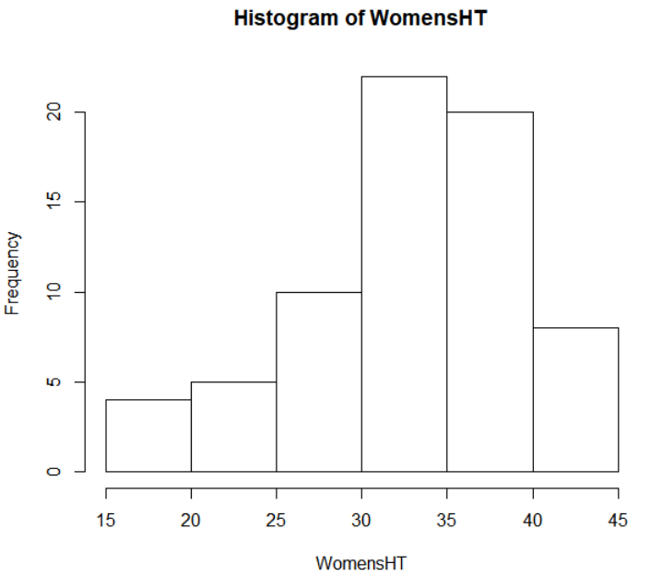

Fig. 68. Histogram of Men’s Hammer All-Americans, with discus marks from high school.

In Figure 69 the numbers tell a similar story with the first quarter starting at 39 meters or 127’11.5”, and the third quarter at 45.24 meters or 148’5”. The average high school mark of the men’s discus being 42.43 meters or 139’0.25”, and the farthest mark being 57.35 meters or 188’2” and the shortest being 28.45 meters or 93’4”. There are eighteen high school marks for the men’s discus that were not found, either being due to the All-American's best high school time and/or second best also not being found



Fig. 69. Summary of Men’s hammer All-Americans, with discus marks from high school.

## 4.3.34 Women’s Hammer

As seen in Figure 70 the discus marks from high school by All-Americans mostly fall in between 35 meters to 50 meters, with small groups lower and higher than this range. The high school marks are all discus marks, as the discus marks are the closest comparison to the hammer throw in college.

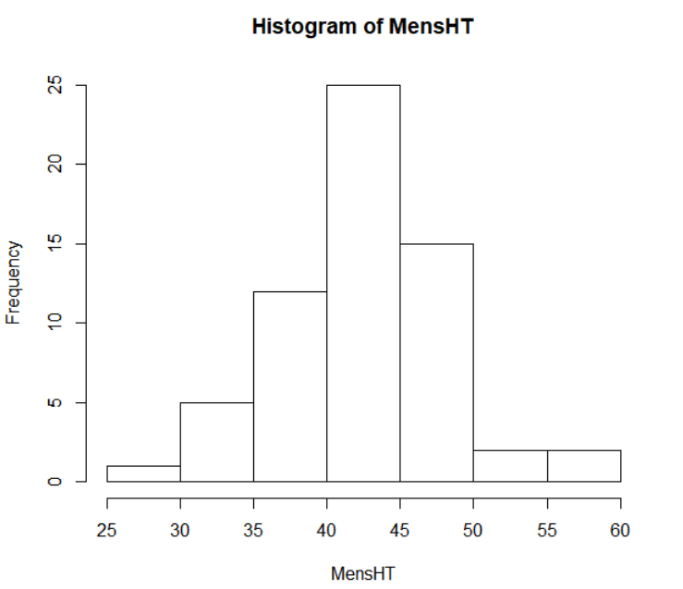

Fig. 70. Histogram of Women’s hammer All-Americans, with discus marks from high school.

In Figure 71 the numbers tell a similar story with the first quarter starting at 29.97 meters or 98’4” and the third quarter at 37.11 meters or 121’9”. The average high school mark of the women’s discus being 32.82 or 107’8”, and the farthest mark being 43.31 meters or 142’1” and the shortest being 17.22 meters or 56’6”. There are eleven high school marks for the women’s discus that were not found, either being due to the All-American's best high school time and/or second best also not being found.



Fig. 71. Summary of Women’s hammer All-Americans, with discus marks from high school.

## 4.4 College PR vs High School PR

Another aspect to look at for the All-Americans is the amount they improved from their high school PR. Here there will be a breakdown between the college PR and the high school PR, looking at the average improvement in college to understand how much athletes might improve in each event. Not every event will be able to be compared due to not being the same event in college and high school; these events are the 5,000-meter, 10,000-meter, 400-meter hurdles, 3,000-meter steeplechase, and hammer throw. The 1,500-meter has been converted to 1,600-meter, so the high school and college times can be compared equally.

## 4.4.1 Men’s 100 Meter

As seen in Figure 72 the 100-meter time of improvement from high school to college by All-Americans mostly fall in between no improvement to 0.75 seconds of improvement, with small amount lower and higher than this range.

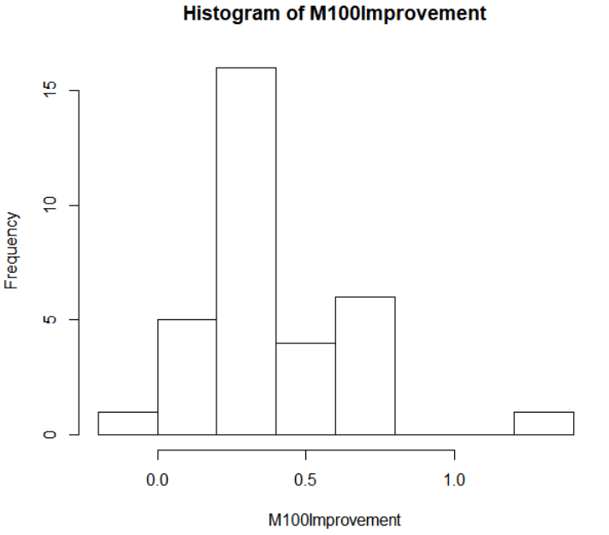

Fig. 72. Histogram of Men’s 100-meter All-Americans amount improved from high school.

In Figure 73 the numbers tell a similar story with the first quarter starting at 0.25 seconds of improvement and the third quarter at 0.59 seconds of improvement. The average high school improvement for the men’s 100-meter being 0.3933 seconds, and the lowest amount of improvement being -0.02 seconds, meaning the high school PR being better than the college PR and the biggest improvement being 1.23 seconds. There are six high school marks for the men’s 100-meter that were not found, due to the All-American's best high school time not being found.



Fig. 73. Summary of Men’s 100-meter All-Americans amount of improvement from high school.

## 4.4.2 Women’s 100 Meter

As seen in Figure 74 the 100-meter time of improvement from high school to college by All-Americans show a vast amount of improvement from no improvement to 1.2 seconds of improvement.

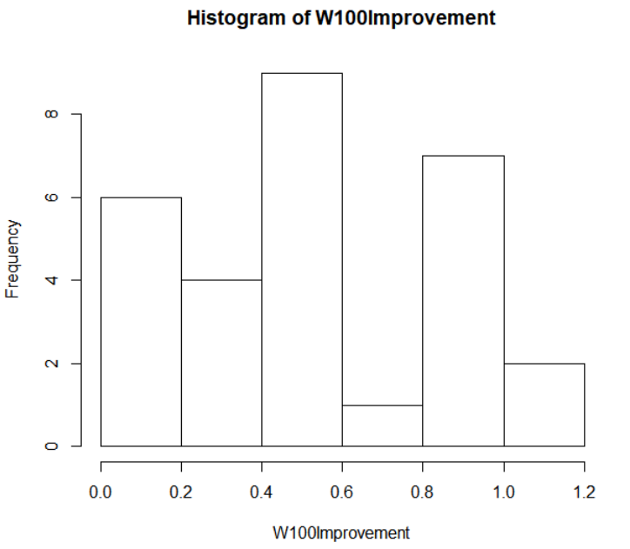

Fig. 74. Histogram of Women’s 100-meter All-Americans amount improved from high school.

In Figure 75 the numbers tell a similar story with the first quarter starting at 0.26 seconds of improvement and the third quarter at 0.84 seconds of improvement. The average high school improvement for the women’s 100-meter being 0.5321 seconds, and the lowest amount of improvement being 0.09 seconds and the biggest improvement being 1.02 seconds. There are eleven high school marks for the women’s 100-meter that were not found, due to the All-American's best high school time not being found.



Fig. 75. Summary of Women’s 100-meter All-Americans amount of improvement from high school.

## 4.4.3 Men’s 200 Meter

As seen in Figure 76 the 200-meter time of improvement from high school to college by All-Americans there is a wide variety from no improvement to 2 seconds of improvement.

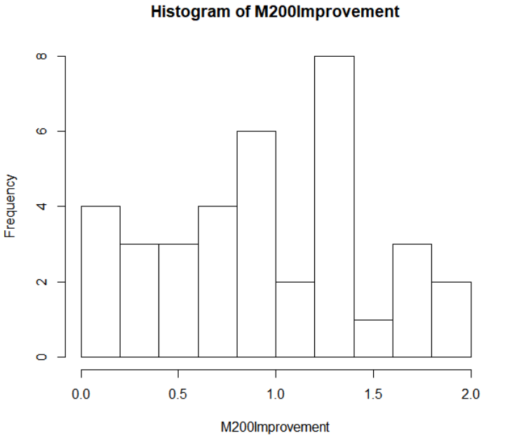

Fig. 76. Histogram of Men’s 200-meter All-Americans amount improved from high school.

In Figure 77 the numbers tell a similar story with the first quarter starting at 0.58 seconds of improvement and the third quarter at 1.37 seconds of improvement. The average high school improvement for the men’s 200-meter being 0.9467 seconds, and the lowest amount of improvement being 0 seconds, meaning the high school PR and the college PR were the same and the biggest improvement being 1.89 seconds. There are four high school marks for the men’s 200-meter that were not found, due to the All-American's best high school time not being found.



Fig. 77. Summary of Men’s 200-meter All-Americans amount of improvement from high school.

## 4.4.4 Women’s 200 Meter

As seen in Figure 78 the 200-meter time of improvement from high school to college by All-Americans show a similar shape to a bell curve, ranging from no improvement to 3.5 seconds of improvement.

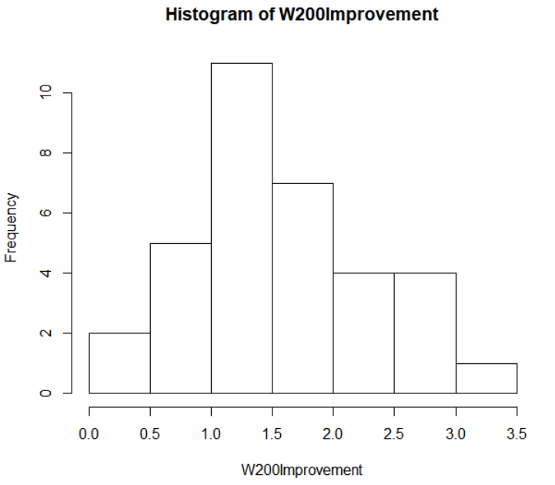

Fig. 78. Histogram of Women’s 200-meter All-Americans amount improved from high school.

In Figure 79 the numbers tell a similar story with the first quarter starting at 1.167 seconds of improvement and the third quarter at 1.97 seconds of improvement. The average high school improvement for the women’s 200-meter being 1.616 seconds, and the lowest amount of improvement being 0.3 seconds and the biggest improvement being 3.49 seconds. There are six high school marks for the women’s 200-meter that were not found, due to the All-American's best high school time not being found.



Fig. 79. Summary of Women’s 200-meter All-Americans amount of improvement from high school.

## 4.4.5 Men’s 400 Meter

As seen in Figure 80 the 400-meter time of improvement from high school to college by All-Americans the majority of the improvement is from 4 seconds to no improvement, with a small amount more than 6 seconds of improvement.

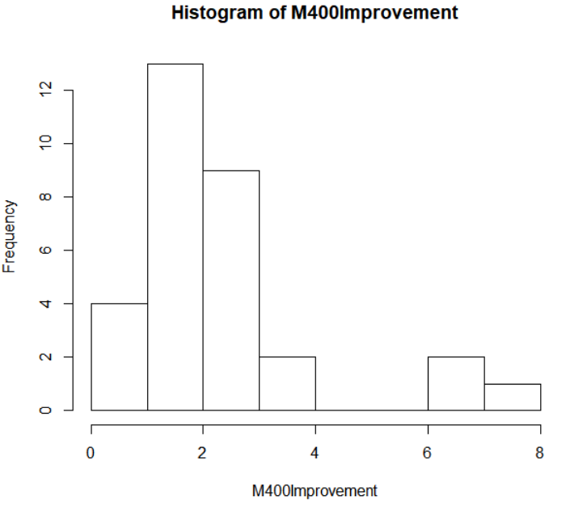

Fig. 80. Histogram of Men’s 400-meter All-Americans amount improved from high school.

In Figure 81 the numbers tell a similar story with the first quarter starting at 1.46 seconds of improvement and the third quarter at 2.81 seconds of improvement. The average high school improvement for the men’s 400-meter being 2.407 seconds, and the lowest amount of improvement being 0.41 seconds and the biggest improvement being 7.21 seconds. There are nine high school marks for the men’s 400-meter that were not found, due to the All-American's best high school time not being found.



Fig. 81. Summary of Men’s 400-meter All-Americans amount of improvement from high school.

## 4.4.6 Women’s 400 Meter

As seen in Figure 82 the 400-meter time of improvement from high school to college by All-Americans have a majority of the improvement from 2 seconds to 4 seconds, with small amounts higher and lower than that range.

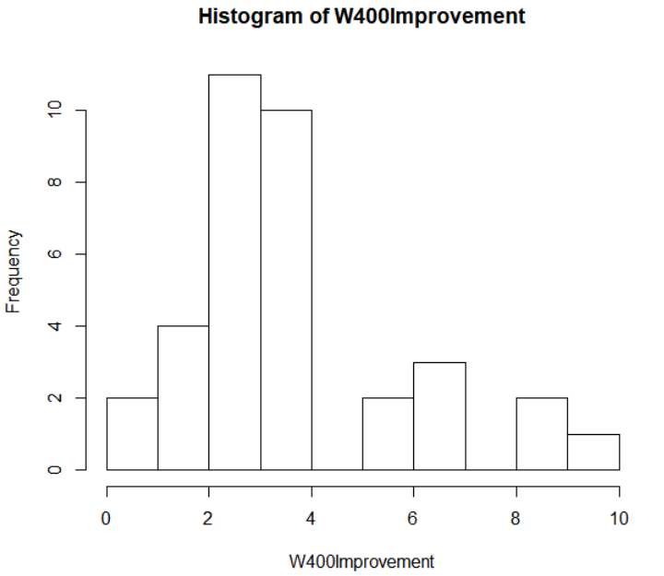

Fig. 82. Histogram of Women’s 400-meter All-Americans amount improved from high school.

In Figure 83 the numbers tell a similar story with the first quarter starting at 2.54 seconds of improvement and the third quarter at 3.75 seconds of improvement. The average high school improvement for the women’s 400-meter being 3.607 seconds, and the lowest amount of improvement being 0.04 seconds and the biggest improvement being 9.26 seconds. There are five high school marks for the women’s 400-meter that were not found, due to the All-American's best high school time not being found.



Fig. 83. Summary of Women’s 400-meter All-Americans amount of improvement from high school.

## 4.4.7 Men’s 800 Meter

As seen in Figure 84 the 800-meter time of improvement from high school to college by All-Americans most of the improvement is from 10 seconds to no improvement, with a small amount more than 10 seconds of improvement.

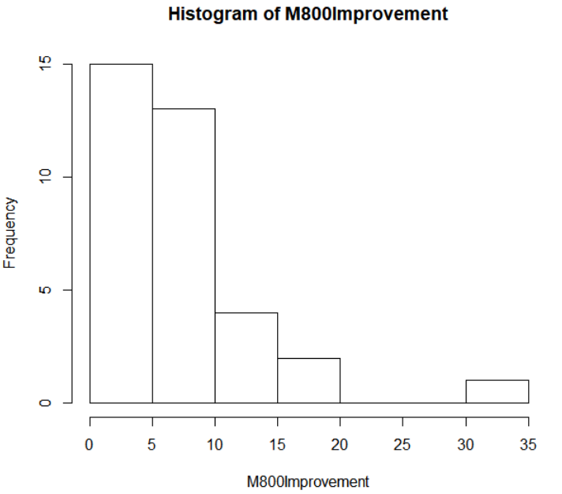

Fig. 84. Histogram of Men’s 800-meter All-Americans amount improved from high school.

In Figure 85 the numbers tell a similar story with the first quarter starting at 4.45 seconds of improvement and the third quarter at 9 seconds of improvement. The average high school improvement for the men’s 800-meter being 7.757 seconds, and the lowest amount of improvement being 1.1 seconds and the biggest improvement being 34.7 seconds. There are five high school marks for the men’s 800-meter that were not found, due to the All-American's best high school time not being found.



Fig. 85. Summary of Men’s 800-meter All-Americans amount of improvement from high school.

## 4.4.8 Women’s 800 Meter

As seen in Figure 86 the 800-meter time of improvement from high school to college by All-Americans have much of the improvement from 5 seconds to 15 seconds, with small amounts higher and lower than that range.

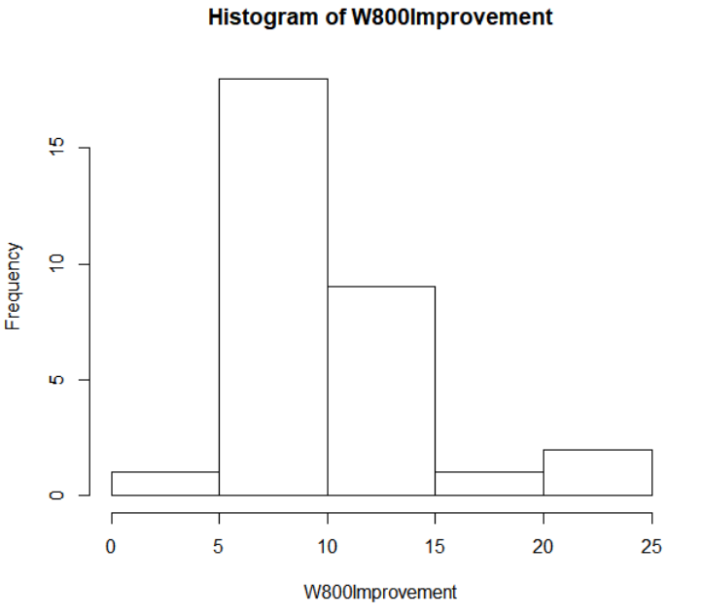

Fig. 86. Histogram of Women’s 800-meter All-Americans amount improved from high school.

In Figure 87 the numbers tell a similar story with the first quarter starting at 7.45 seconds of improvement and the third quarter at 12 seconds of improvement. The average high school improvement for the women’s 800-meter being 10.08 seconds, and the lowest amount of improvement being 1.3 seconds and the biggest improvement being 21.8 seconds. There are nine high school marks for the women’s 800-meter that were not found, due to the All-American's best high school time not being found.



Fig. 87. Summary of Women’s 800-meter All-Americans amount of improvement from high school.

## 4.4.9 Men’s 1,500 Meter

As seen in Figure 88 the 1,600-meter time of improvement from high school to college by All-Americans most of the improvement is from 10 seconds to 25 seconds, with a small amount more than 25 seconds of improvement and a couple lower than 10 seconds of improvement. The college PR’s have been converted from 1,500-meter times to 1,600-meter times to be compared to the high school 1,600-meter PR’s.

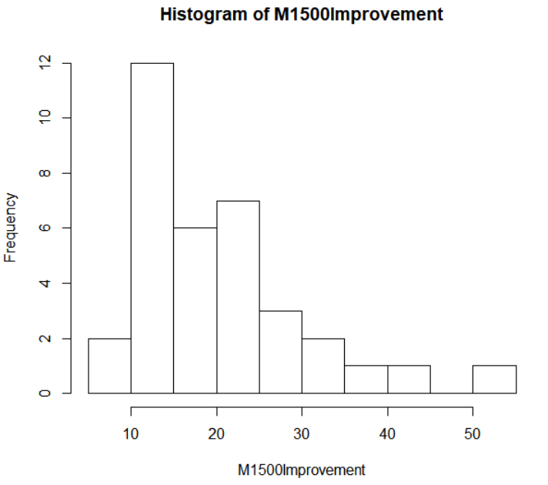

Fig. 88. Histogram of Men’s 1,500-meter All-Americans, with the 1,600-meter amount improved from high school.

In Figure 89 the numbers tell a similar story with the first quarter starting at 13.75 seconds of improvement and the third quarter at 23.6 seconds of improvement. The average high school improvement for the men’s 1,600-meter being 20.23 seconds, and the lowest amount of improvement being 8.4 seconds and the biggest improvement being 51 seconds. There are five high school marks for the men’s 1,600-meter that were not found, due to the All-American's best high school time not being found.



Fig. 89. Summary of Men’s 1,500-meter All-Americans, with the 1,600-meter amount of improvement from high school.

## 4.4.10 Women’s 1,500 Meter

As seen in Figure 90 the 1,600-meter time of improvement from high school to college by All-Americans have most of the improvement from 10 seconds to 40 seconds, with more improvement higher and lower than that range. The college PR’s have been converted from 1,500-meter times to 1,600-meter times to be compared to the high school 1,600-meter PR’s.

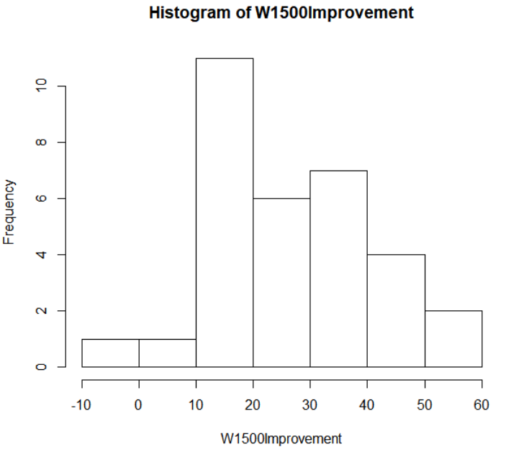

Fig. 90. Histogram of Women’s 1,500-meter All-Americans, with 1,600-meter amount improved from high school.

In Figure 91 the numbers tell a similar story with the first quarter starting at 14.95 seconds of improvement and the third quarter at 38.15 seconds of improvement. The average high school improvement for the women’s 1,600-meter being 26.41 seconds, and the lowest amount of improvement being -4 seconds, meaning the high school PR being better than the college PR and the biggest improvement being 56.4 seconds. There are eight high school marks for the women’s 1,600-meter that were not found, due to the All-American's best high school time not being found.



Fig. 91. Summary of Women’s 1,500-meter All-Americans, with 1,600-meter amount of improvement from high school.

## 4.4.11 Men’s 110 Meter Hurdles

As seen in Figure 92 the 110-meter hurdles time of improvement from high school to college by All-Americans majority of the improvements fall in between 1 second to no improvement, with small amounts higher and lower than the one second range.

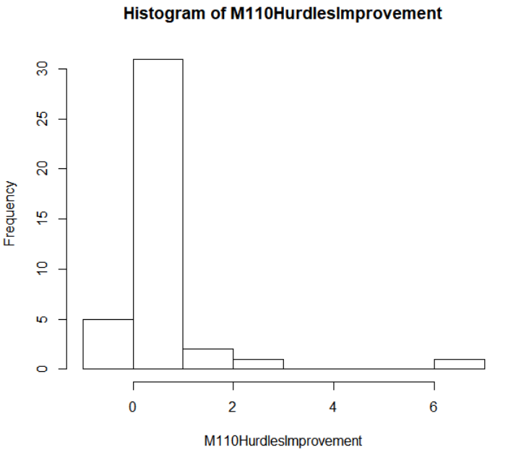

Fig. 92. Histogram of Men’s 110-meter hurdles All-Americans amount improved from high school.

In Figure 93 the numbers tell a similar story with the first quarter starting at 0.1775 seconds of improvement and the third quarter at 0.6875 seconds of improvement. The average high school improvement for the men’s 110-meter hurdles being 0.6438 seconds, and the lowest amount of improvement being -0.09 seconds, meaning the high school PR being better than the college PR and the biggest improvement being 6.72 seconds.



Fig. 93. Summary of Men’s 110-meter hurdles All-Americans amount of improvement from high school.

## 4.4.12 Women’s 100 Meter Hurdles

As seen in Figure 94 the 100-meter hurdles time of improvement from high school to college by All-Americans have a gradual increase through 1.5 seconds of improvement, with a drop off higher than 1.5 seconds of improvement.

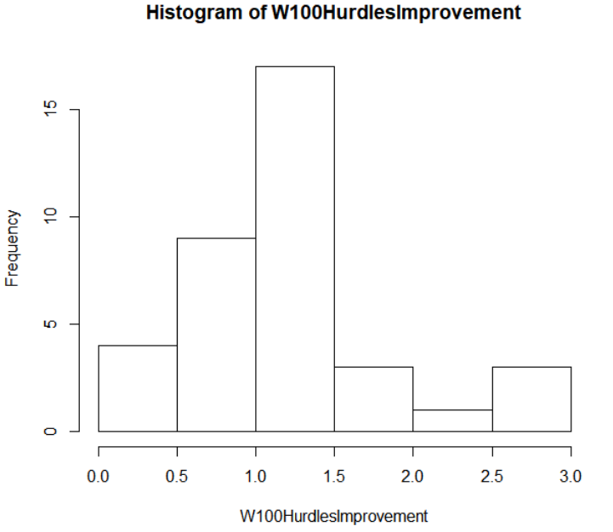

Fig. 94. Histogram of Women’s 100-meter hurdles All-Americans amount improved from high school.

In Figure 95 the numbers tell a similar story with the first quarter starting at 0.75 seconds of improvement and the third quarter at 1.45 seconds of improvement. The average high school improvement for the women’s 100-meter hurdles being 1.192 seconds, and the lowest amount of improvement being 0.17 seconds and the biggest improvement being 2.86 seconds. There are three high school marks for the women’s 100-meter hurdles that were not found, due to the All-American's best high school time not being found.



Fig. 95. Summary of Women’s 100-meter hurdles All-Americans amount of improvement from high school.

## 4.4.13 Men’s High Jump

As seen in Figure 96 the high jump distance of improvement from high school to college by All-Americans a good amount of the improvements falls in between from 0.05 meters to 0.15 meters, with a gradual decline in the amount as the increase in the amount of improvement.

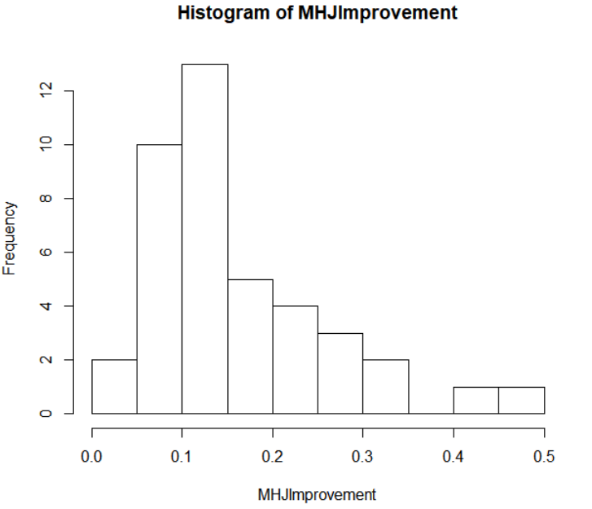

Fig. 96. Histogram of Men’s high jump All-Americans amount improved from high school.

In Figure 97 the numbers tell a similar story with the first quarter starting at 0.089 meters of improvement and the third quarter at 0.209 meters of improvement. The average high school improvement for the men’s high jump being 0.1656 meters, and the lowest amount of improvement being 0.011 and the biggest improvement being 0.475 meters. There are two high school marks for the men’s high jump that were not found, due to the All-American's best high school time not being found.



Fig. 97. Summary of Men’s high jump All-Americans amount of improvement from high school.

## 4.4.14 Women’s High Jump

As seen in Figure 98 the high jump distance of improvement from high school to college by All-Americans there is a gradual decline from no improvement to 0.25 meters, with one mark being lower than no improvement.

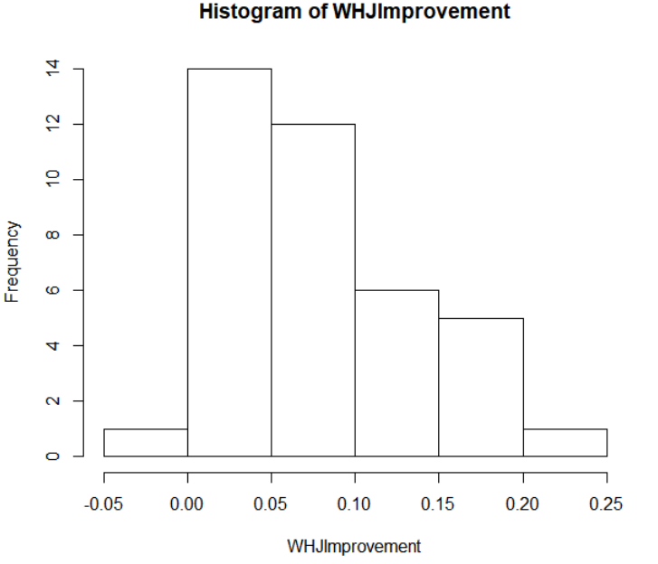

Fig. 98. Histogram of Women’s high jump All-Americans amount improved from high school.

In Figure 99 the numbers tell a similar story with the first quarter starting at 0.034 meters of improvement and the third quarter at 0.119 meters of improvement. The average high school improvement for the women’s high jump being 0.07726 meters, and the lowest amount of improvement being -0.001 meters and the biggest improvement being 0.226 meters. There are three high school marks for the women’s high jump that were not found, due to the All-American's best high school time not being found.



Fig. 99. Summary of Women’s high jump All-Americans amount of improvement from high school.

## 4.4.15 Men’s Pole Vault

As seen in Figure 100 the pole vault distance of improvement from high school to college by All-Americans with a majority of the improvement from 0.2 meters to 0.8 meters, with small amounts higher than that range.

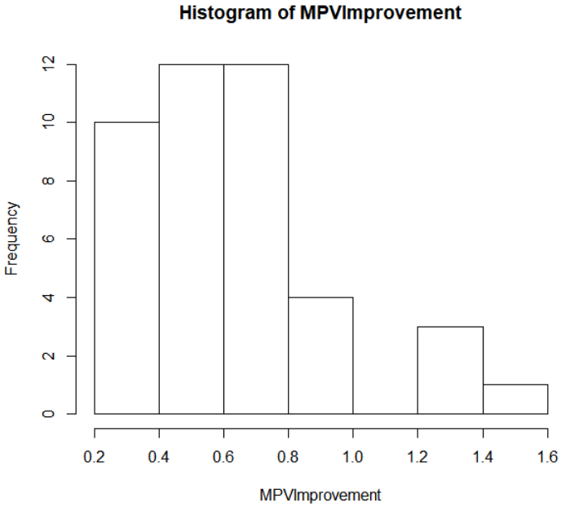

Fig. 100. Histogram of Men’s pole vault All-Americans amount improved from high school.

In Figure 101 the numbers tell a similar story with the first quarter starting at 0.4363 meters of improvement and the third quarter at 0.727 meters of improvement. The average high school improvement for the men’s pole vault being 0.6198 meters, and the lowest amount of improvement being 0.254 and the biggest improvement being 1.405 meters.



Fig. 101. Summary of Men’s pole vault All-Americans amount of improvement from high school.

## 4.4.16 Women’s Pole Vault

As seen in Figure 102 the pole vault distance of improvement from high school to college by All-Americans looking like a bell curve.

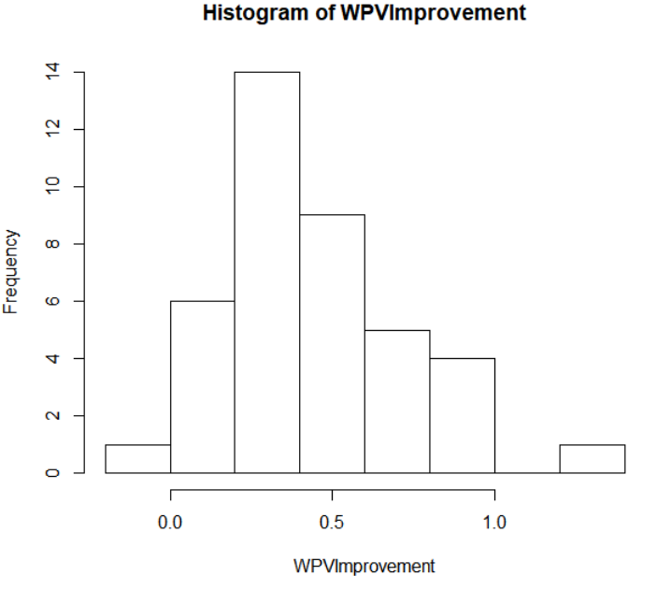

Fig. 102. Histogram of Women’s pole vault All-Americans amount improved from high school.

In Figure 103 the numbers tell a similar story with the first quarter starting at 0.243 meters of improvement and the third quarter at 0.582 meters of improvement. The average high school improvement for the women’s pole vault being 0.4406 meters, and the lowest amount of improvement being -0.013 meters and the biggest improvement being 1.205 meters. There are three high school marks for the women’s pole vault that were not found, due to the All-American's best high school time not being found.



Fig. 103. Summary of Women’s pole vault All-Americans amount of improvement from high school.

## 4.4.17 Men’s Long Jump

As seen in Figure 104 the long jump distance of improvement from high school to college by All-Americans with a bulk of the improvement from no improvement to 1 meter, with small amounts higher than that range.

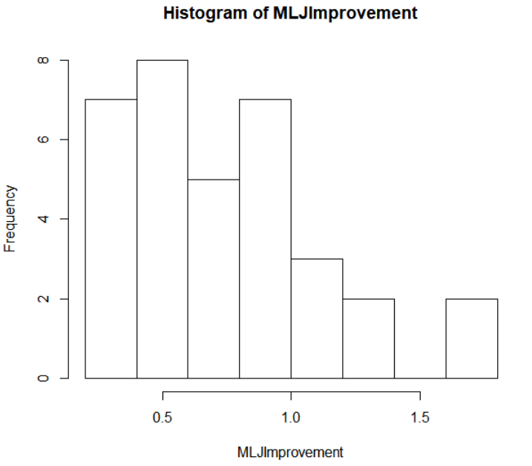

Fig. 104. Histogram of Men’s long jump All-Americans amount improved from high school.

In Figure 105 the numbers tell a similar story with the first quarter starting at 0.4815 meters of improvement and the third quarter at 0.9203 meters of improvement. The average high school improvement for the men’s long jump being 0.7496 meters, and the lowest amount of improvement being 0.246 meters and the biggest improvement being 1.756 meters. There are six high school marks for the men’s long jump that were not found, due to the All-American's best high school time not being found.



Fig. 105. Summary of Men’s long jump All-Americans amount of improvement from high school.

## 4.4.18 Women’s Long Jump

As seen in Figure 106 the long jump distance of improvement from high school to college by All-Americans with the graph looking fairly even except from the improvement from 0.2 meters to 0.4 meters, while it spiked.

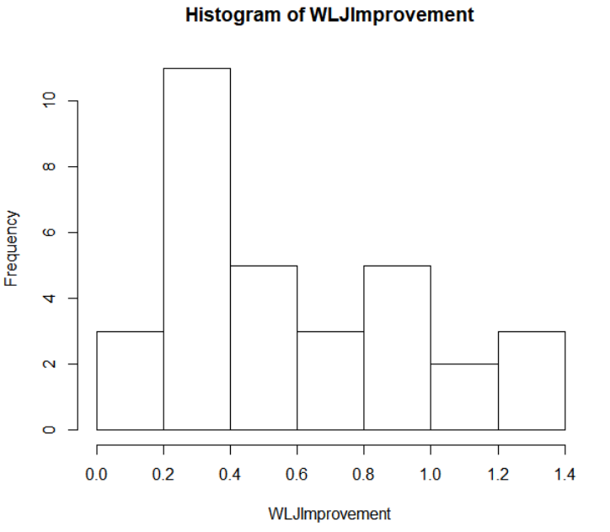

Fig. 106. Histogram of Women’s long jump All-Americans amount improved from high school.

In Figure 107 the numbers tell a similar story with the first quarter starting at 0.3262 meters of improvement and the third quarter at 0.8137 meters of improvement. The average high school improvement for the women’s long jump being 0.5684 meters, and the lowest amount of improvement being 0.064 meters and the biggest improvement being 1.264 meters. There are eight high school marks for the women’s long jump that were not found, due to the All-American's best high school time not being found.



Fig. 107. Summary of Women’s long jump All-Americans amount of improvement from high school.

## 4.4.19 Men’s Triple Jump

As seen in Figure 108 the long jump distance of improvement from high school to college by All-Americans with a majority of the improvement from 0.5 meters to 2 meters, with small amounts higher and lower than that range.

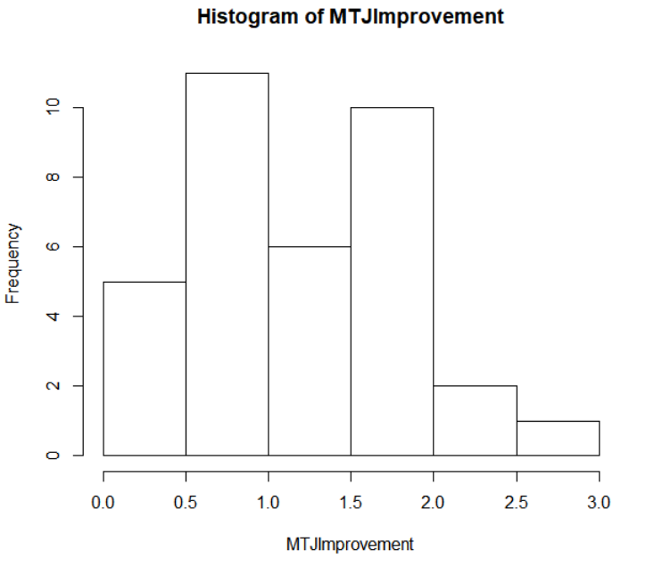

Fig. 108. Histogram of Men’s triple jump All-Americans amount improved from high school.

In Figure 109 the numbers tell a similar story with the first quarter starting at 0.7505 meters of improvement and the third quarter at 1.678 meters of improvement. The average high school improvement for the men’s triple jump being 1.1848 meters, and the lowest amount of improvement being 0.04 meters and the biggest improvement being 2.629 meters. There are five high school marks for the men’s triple jump that were not found, due to the All-American's best high school time not being found.



Fig. 109. Summary of Men’s triple jump All-Americans amount of improvement from high school.

## 4.4.20 Women’s Triple Jump

As seen in Figure 110 the triple jump distance of improvement from high school to college by All-Americans and most of improvements are from 0.25 meters to 1.25 meters, with small amounts outside of that range.

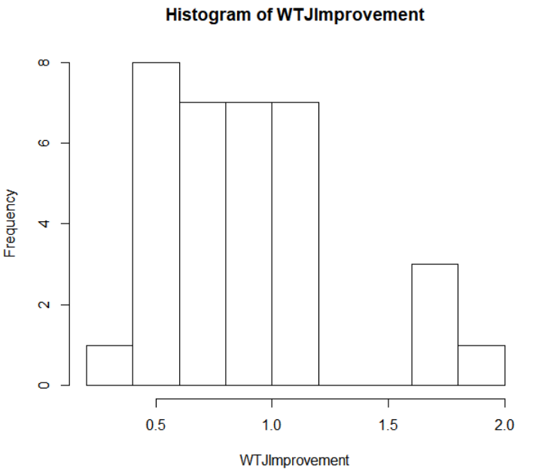

Fig. 110. Histogram of Women’s triple jump All-Americans amount improved from high school.

In Figure 111 the numbers tell a similar story with the first quarter starting at 0.7505 meters of improvement and the third quarter at 1.678 meters of improvement. The average high school improvement for the women’s triple jump being 1.1848 meters, and the lowest amount of improvement being 0.04 meters and the biggest improvement being 2.629 meters. There are five high school marks for the women’s triple jump that were not found, due to the All-American's best high school time not being found.



Fig. 111. Summary of Women’s triple jump All-Americans amount of improvement from high school.

## 4.4.21 Men’s Shot Put

As seen in Figure 112 the shot put distance of improvement from high school to college by All-Americans with most of the improvement from -1 meters to 2 meters, with small amounts higher and lower than that range.

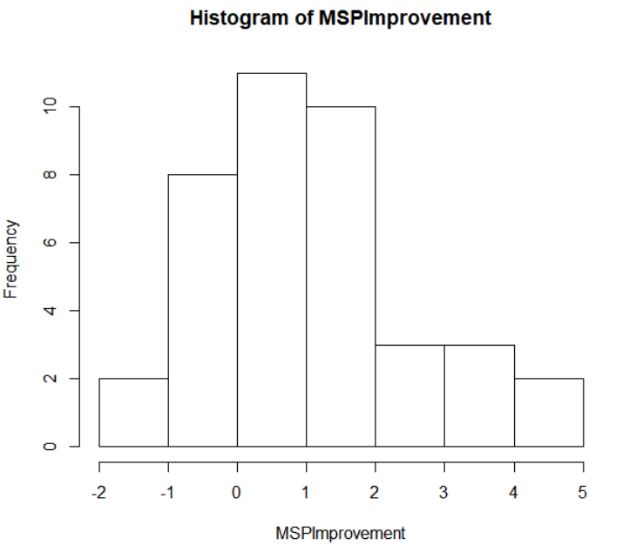

Fig. 112. Histogram of Men’s shot put All-Americans amount improved from high school.

In Figure 113 the numbers tell a similar story with the first quarter starting at 0.0285 meters of improvement and the third quarter at 1.663 meters of improvement. The average high school improvement for the men’s shot put being 1.663 meters, and the lowest amount of improvement being -1.197 meters and the biggest improvement being 4.102 meters. There are one high school marks for the men’s shot put that were not found, due to the All-American's best high school time not being found.



Fig. 113. Summary of Men’s shot put All-Americans amount of improvement from high school.

## 4.4.22 Women’s Shot Put

As seen in Figure 114 the shot put distance of improvement from high school to college by All-Americans with different variety of improvement with a spike from 2 meters to 2.5 meters.

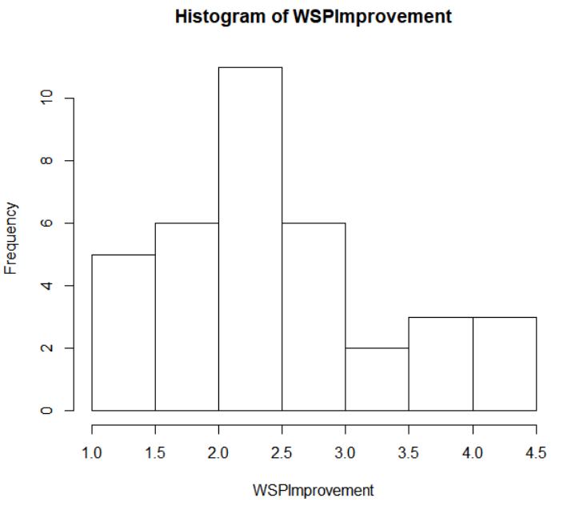

Fig. 114. Histogram of Women’s shot put All-Americans amount improved from high school.

In Figure 115 the numbers tell a similar story with the first quarter starting at 1.833 meters of improvement and the third quarter at 2.786 meters of improvement. The average high school improvement for the women’s shot put being 2.413 meters, and the lowest amount of improvement being 1.052 meters and the biggest improvement being 4.01 meters. There are four high school marks for the women’s shot put that were not found, due to the All-American's best high school time not being found.



Fig. 115. Summary of Women’s shot put All-Americans amount of improvement from high school.

## 4.4.23 Men’s Discus

As seen in Figure 116 the discus distance of improvement from high school to college by All-Americans with most of the improvement from -5 meters to 10 meters, with small amounts higher than that range.

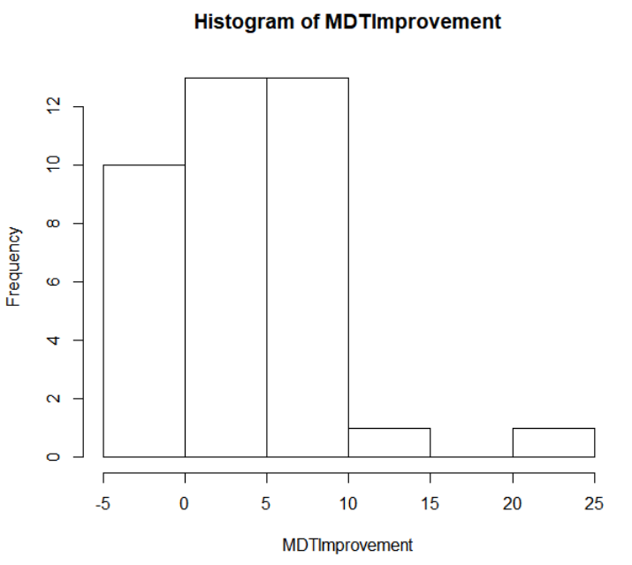

Fig. 116. Histogram of Men’s discus All-Americans amount improved from high school.

In Figure 117 the numbers have a vast variety of improvements with the first quarter starting at –0.061 meters of improvement and the third quarter at 7.299 meters of improvement. The average high school improvement for the men’s discus being 3.964 meters, and the lowest amount of improvement being -2.237 meters and the biggest improvement being 20.475 meters. There are two high school marks for the men’s discus that were not found, due to the All-American's best high school time not being found.



Fig. 117. Summary of Men’s discus All-Americans amount of improvement from high school.

## 4.4.24 Women’s Discus

As seen in Figure 118 the discus distance of improvement from high school to college by All-Americans with most of the improvements in between 7.5 meters to 10 meters, with small amounts higher and lower than that range.

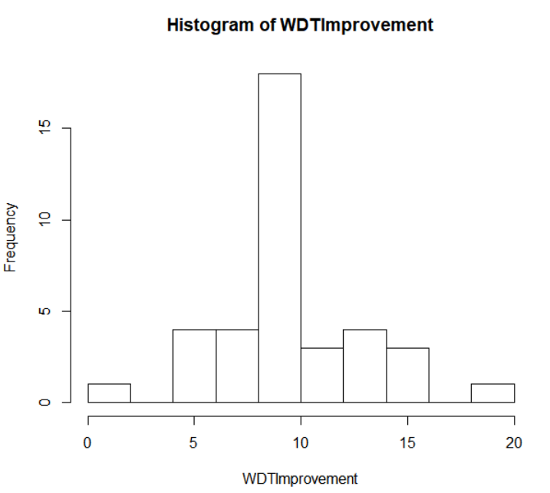

Fig. 118. Histogram of Women’s discus All-Americans amount improved from high school.

In Figure 119 the numbers tell a similar story with the first quarter starting at 8.059 meters of improvement and the third quarter at 10.322 meters of improvement. The average high school improvement for the women’s discus being 9.422 meters, and the lowest amount of improvement being 1.823 meters and the biggest improvement being 18.073 meters. There are two high school marks for the women’s discus that were not found, due to the All-American's best high school time not being found.



Fig. 119. Summary of Women’s discus All-Americans amount of improvement from high school.

## 4.5 Decathlon

The Decathlon dataset is looking at the high school events the decathlon All-Americans participated in. It contains nine out of the ten events, as javelin is uncommon event in high school track and field. The aspects that were analyzed in the Decathlon dataset are the same as the All-American dataset with looking at the break down of each event’s high school times and marks and looking at the improvement of each event from high school to college. Another aspect that will be analyzed that is different from the All-American dataset is looking at how many decathlons athletes participated in each event in high school, to find which events done in high school are more likely to turn out an All-American Decathlon athlete.

## 4.5.1 Events of Decathlon in High School

The number of All-Americans that participated in high school is a good way to find what high school athletes to recruit to become a Decathlon athlete in college. In Wisconsin high school track and field, athletes are allowed to participate in four events max, with at most three of them either being field or running events. The top four events that are participated in high school by the Decathlon All-American athletes will be taken into consideration as the type of athletes that will be looked at as potential Decathlon athletes in college. As in figure 120 the top four events participated in from Decathlon All-Americans are High Jump, 110-meter Hurdles, Long Jump, and 400-meter. There is a drop off after the top three events, High Jump, 110-meter Hurdles, and Long Jump. Clearly the 1,600-meter event is the least participated in from Decathlon’s in high school.

Fig. 120. Summary of Decathlon’s All-Americans participation in events from high school.

## 4.5.2 Decathlon High School Times by Event

This section will break down by event what the high school times and marks of the event are good based off the times and marks of the Decathlon's. The breakdown of this analysis shows histograms as a visual way to see where an average of the Decathlon's performed in high school. There are numbers to help better understand the knowledge the histogram is showing

## 4.5.2.1 Decathlon 100-meter

As seen in Figure 121, the 100-meter times from high school by Decathlon with a wide variety of times from 11 seconds to 13 seconds.

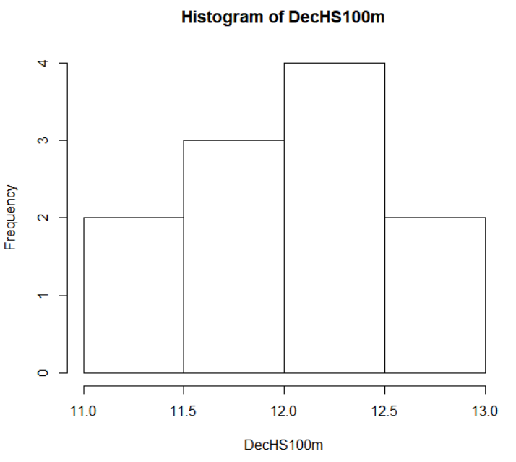

Fig. 121. Histogram of Decathlon 100-meter times from high school.

In Figure 122 the numbers tell a similar story with the first quarter starting at 11.57 seconds and the third quarter at 12.46 seconds. The average high school time for the Decathlon 100-meter being 12.05 seconds, and the slowest time being 12.84 seconds and the fastest time being 11.27 seconds. There are twenty-nine high school times for the Decathlon 100-meter that were not found, due to the Decathlon's best high school time not being found.



Fig. 122. Summary of Decathlon 100-meter times from high school.

## 4.5.2.2 Decathlon 400-meter

As seen in Figure 123, the 400-meter times from high school by Decathlon with a wide variety of times from 48 seconds to 60 seconds.

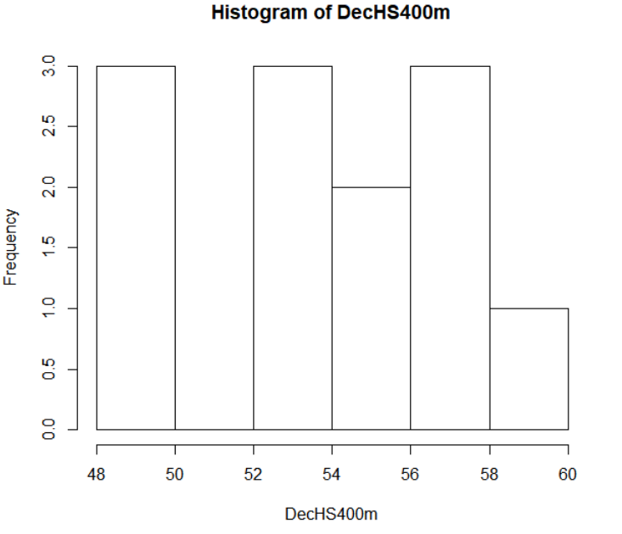

Fig. 123. Histogram of Decathlon 400-meter times from high school.

In Figure 124 the numbers tell a similar story with the first quarter starting at 51.23 seconds and the third quarter at 57.12 seconds. The average high school time for the Decathlon 400-meter being 53.78 seconds, and the slowest time being 58.20 seconds and the fastest time being 49.21 seconds. There are twenty-eight high school times for the Decathlon 400-meter that were not found, due to the Decathlon's best high school time not being found.



Fig. 124. Summary of Decathlon 400-meter times from high school.

## 4.5.2.3 Decathlon 1,600-meter

There are two 1,600-meter high school times for the Decathlon dataset, which is a small amount to analyze. According to phy.listu.edu, the number of data points which are enough to analyze the data is found to be six data points. Since there are only two data points for the Decathlon’s 1,600-meter the data cannot be analyzed.

## 4.5.2.4 Decathlon 110-meter Hurdles

As seen in Figure 125, the 110-meter hurdles times from high school by Decathlon with a wide variety of times, with a big spike from 15 seconds to 16 seconds.

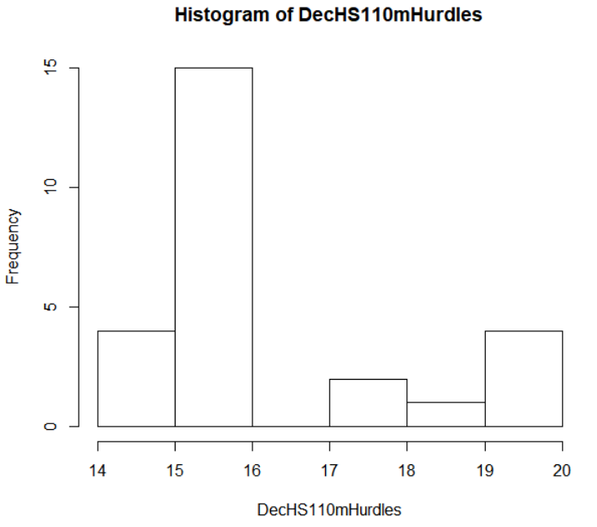

Fig. 125. Histogram of Decathlon 110-meter hurdles times from high school.

In Figure 126 the numbers tell a similar story with the first quarter starting at 15.12 seconds and the third quarter at 16.87 seconds. The average high school time for the Decathlon 110-meter hurdles being 16.16 seconds, and the slowest time being 19.23 seconds and the fastest time being 14.68 seconds. There are fourteen high school times for the Decathlon 110-meter hurdles that were not found, due to the Decathlon's best high school time not being found.



Fig. 126. Summary of Decathlon 110-meter hurdles times from high school.

## 4.5.2.5 Decathlon Long Jump

As seen in Figure 127, the Long Jump marks from high school by Decathlon with a wide variety of times, with up and down amount from 5 meters to 7 meters.

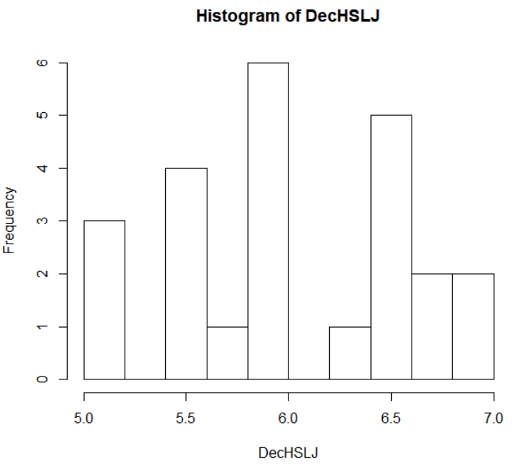

Fig. 127. Histogram of Decathlon Long Jump marks from high school.

In Figure 128 the numbers tell a similar story with the first quarter starting at 5.582 meters and the third quarter at 6.527 meters. The average high school mark for the Decathlon long jump being 6.031 meters, and the lowest mark being 5.181 meters and the highest mark being 6.858 meters. There are sixteen high school marks for the Decathlon long jump that were not found, due to the Decathlon's best high school time not being found.



Fig. 128. Summary of Decathlon Long jump marks from high school.

## 4.5.2.6 Decathlon High Jump

As seen in Figure 129, the High Jump marks from high school by Decathlon with a gradual increase in the amount as the distance increases, with a couple down distances.

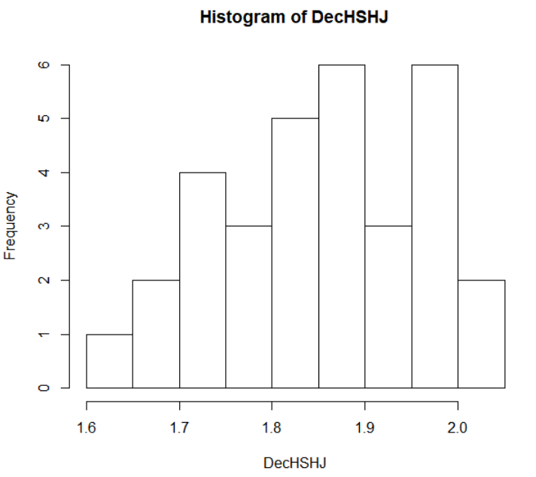

Fig. 129. Histogram of Decathlon High Jump marks from high school.

In Figure 130 the numbers tell a similar story with the first quarter starting at 1.778 meters and the third quarter at 1.936 meters. The average high school mark for the Decathlon high jump being 1.856 meters, and the shortest mark being 1.63 meters and the highest mark being 2.006 meters. There are eight high school marks for the Decathlon high jump that were not found, due to the Decathlon's best high school time not being found.



Fig. 130. Summary of Decathlon high jump marks from high school.

## 4.5.2.7 Decathlon Pole Vault

As seen in Figure 131, the Pole Vault marks from high school by Decathlon with a gradual decrease in the amount as the distance increases.

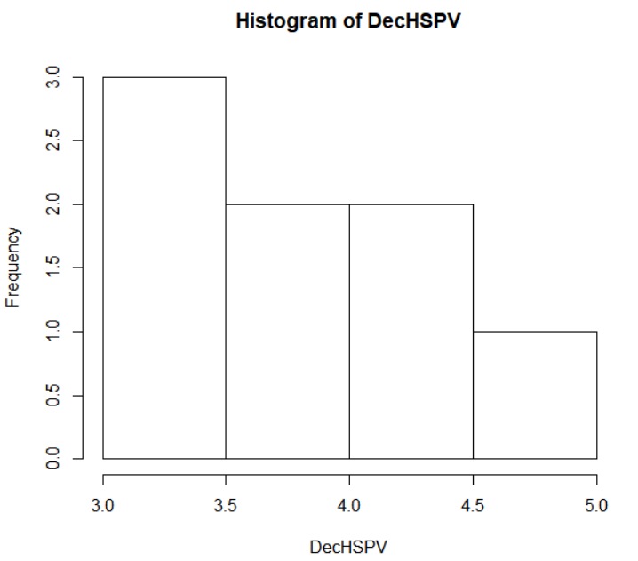

Fig. 131. Histogram of Decathlon Pole Vault marks from high school.

In Figure 132 the numbers tell a similar story with the first quarter starting at 3.2 meters and the third quarter at 4.19 meters. The average high school mark for the Decathlon pole vault being 3.791 meters, and the shortest mark being 3.2 meters and the highest mark being 4.724 meters. There are thirty-two high school marks for the Decathlon pole vault that were not found, due to the Decathlon's best high school time not being found.



Fig. 132. Summary of Decathlon pole vault marks from high school.

## 4.5.2.8 Decathlon Shot Put

As seen in Figure 133, the Shot Put marks from high school by Decathlon with all but two marks fall in between 12 meters to 13 meters, one higher and one lower than the range.

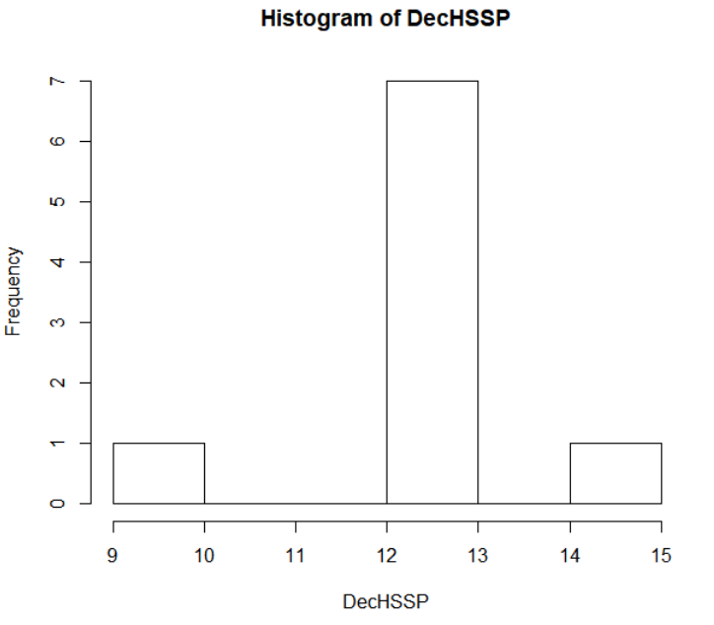

Fig. 133. Histogram of Decathlon Shot Put marks from high school.

In Figure 134 the numbers tell a similar story with the first quarter starting at 12.249 meters and the third quarter at 12.89 meters. The average high school mark for the Decathlon shot put being 12.283 meters, and the shortest mark being 9.347 meters and the farthest mark being 14.02 meters. There are thirty-one high school marks for the Decathlon pole vault that were not found, due to the Decathlon's best high school time not being found.



Fig. 134. Summary of Decathlon shot put marks from high school.

## 4.5.2.9 Decathlon Discus

As seen in Figure 135, the Discus marks from high school by Decathlon with all but two marks fall in between 35 meters to 40 meters, one higher and one lower than the range.

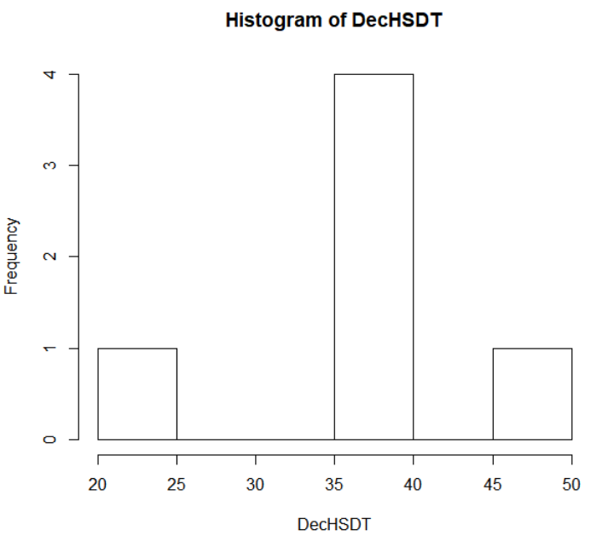

Fig. 135. Histogram of Decathlon Discus marks from high school.

In Figure 136 the numbers tell a similar story with the first quarter starting at 35.82 meters and the third quarter at 36.07 meters. The average high school mark for the Decathlon discus being 35.65 meters, and the shortest mark being 21.29 meters and the farthest mark being 48.67 meters. There are thirty-four high school marks for the Decathlon discus that were not found, due to the Decathlon's best high school time not being found.



Fig. 136. Summary of Decathlon discus marks from high school.

## 4.5.3 Decathlon High School PR vs College PR

Another aspect to look at for the Decathlons is the amount they improved from their high school PR. Here there will be a breakdown between the college PR and the high school PR, looking at the average improvement in college to understand how much athletes might improve in each event. Not every event will be able to be compared as the 1,500-meter only has two high school times, which is too few data points to analyze.

## 4.5.3.1 Decathlon 100-meter

As seen in Figure 137, the 100-meter improvement from high school by Decathlon are bunched in two different groups.

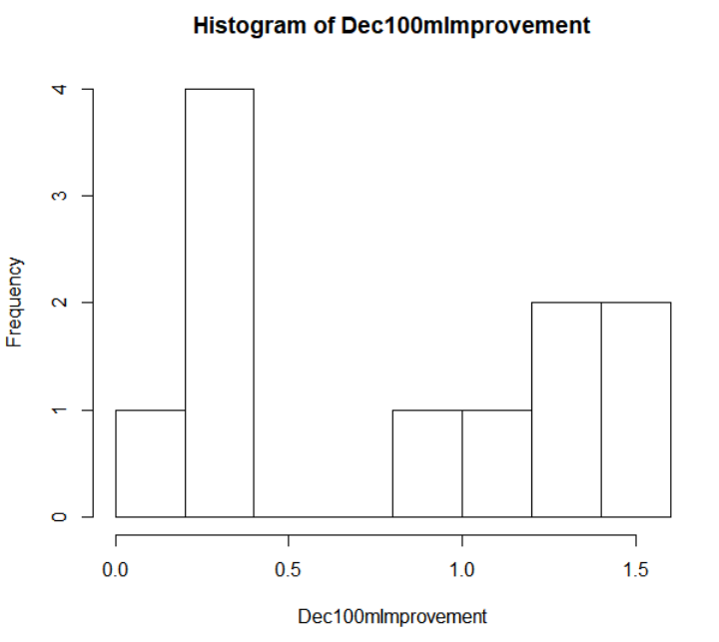

Fig. 137. Histogram of Decathlon 100-meter amount improved from high school.

In Figure 138 the numbers tell a similar story with the first quarter starting at 0.27 seconds of improvement and the third quarter at 1.315 seconds of improvement. The average high school improvement for the Decathlon 100-meter being 0.81 seconds, and the lowest improvement being 0.18 seconds and the biggest improvement being 1.48 seconds. There are twenty-nine high school times for the Decathlon 100-meter that were not found, due to the Decathlon's best high school time not being found.



Fig. 138. Summary of Decathlon 100-meter amount improved from high school.

## 4.5.3.2 Decathlon 400-meter

As seen in Figure 139, the 400-meter improvement from high school by Decathlon with two spikes from no improvement to 2 seconds and 6 seconds to 8 seconds, with small amounts between the ranges and another higher than the rest.

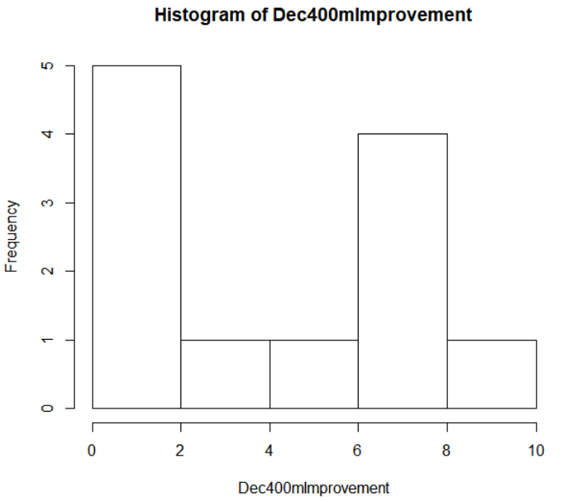

Fig. 139. Histogram of Decathlon 400-meter amount improved from high school.

In Figure 140 the numbers tell a similar story with the first quarter starting at 1.41 seconds of improvement and the third quarter at 6.2 seconds of improvement. The average high school improvement for the Decathlon 400-meter being 3.947 seconds, and the lowest improvement being 0.99 seconds and the biggest improvement being 8.17 seconds. There are twenty-eight high school times for the Decathlon 400-meter that were not found, due to the Decathlon's best high school time not being found.



Fig. 140. Summary of Decathlon 400-meter amount improved from high school.

## 4.5.3.3 Decathlon 110-meter Hurdles

As seen in Figure 141, the 110-meter hurdles improvement from high school by Decathlon with a variety of improvements with a spike from no improvement to 1 second and small amounts between the higher and lower than the range.

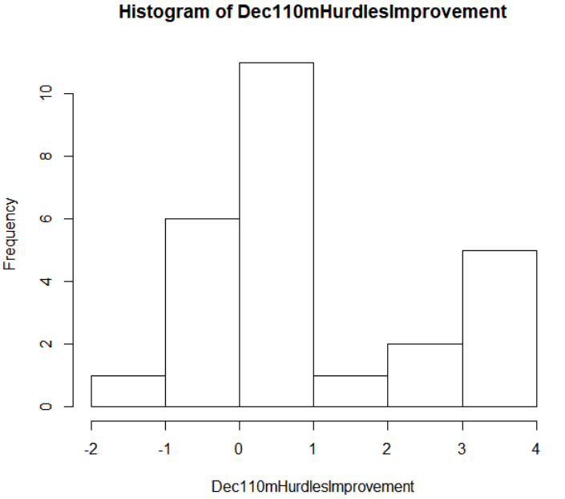

Fig. 141. Histogram of Decathlon 110-meter hurdles amount improved from high school.

In Figure 142 the numbers tell a similar story with the first quarter starting at 0.015 seconds of improvement and the third quarter at 1.903 seconds of improvement. The average high school improvement for the Decathlon 110-meter hurdles being 0.97 seconds, and the lowest improvement being -1.15 seconds and the biggest improvement being 3.99 seconds. There are fourteen high school times for the Decathlon 110-meter hurdles that were not found, due to the Decathlon's best high school time not being found.



Fig. 142. Summary of Decathlon 110-meter hurdles amount improved from high school.

## 4.5.3.4 Decathlon Long Jump

As seen in Figure 143, the long jump improvement from high school by Decathlon with a decrease in amount as the improvement increases.

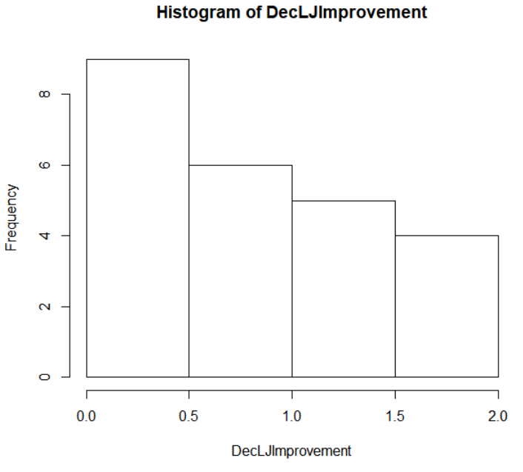

Fig. 143. Histogram of Decathlon long jump amount improved from high school.

In Figure 144 the numbers tell a similar story with the first quarter starting at 0.4012 meters of improvement and the third quarter at 1.1125 meters of improvement. The average high school improvement for the Decathlon long jump being 0.8515 meters, and the lowest improvement being 0.073 meters and the biggest improvement being 1.999 meters. There are sixteen high school marks for the Decathlon long jump that were not found, due to the Decathlon's best high school time not being found.



Fig. 144. Summary of Decathlon long jump amount improved from high school.

## 4.5.3.5 Decathlon High Jump

As seen in Figure 145, the high jump improvement from high school by Decathlon show a similar look to a bell curve.

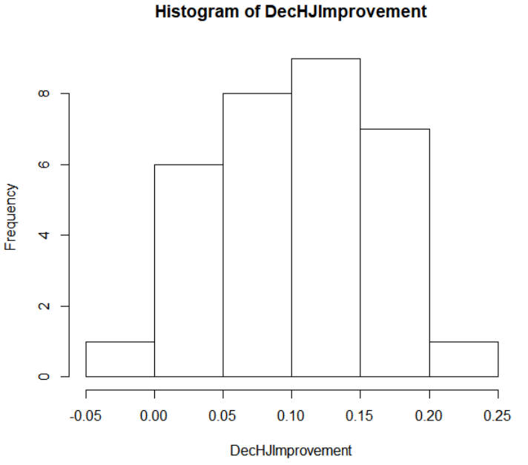

Fig. 145. Histogram of Decathlon high jump amount improved from high school.

In Figure 146 the numbers tell a similar story with the first quarter starting at 0.0585 meters of improvement and the third quarter at 0.1368 meters of improvement. The average high school improvement for the Decathlon high jump being 0.1 meters, and the lowest improvement being -0.001 meters and the biggest improvement being 0.234 meters. There are eight high school marks for the Decathlon high jump that were not found, due to the Decathlon's best high school time not being found.



Fig. 146. Summary of Decathlon high jump amount improved from high school.

## 4.5.3.6 Decathlon Pole Vault

As seen in Figure 147, the pole vault improvement from high school by Decathlon with a spike from 1 meter to 1.2 meter with small groups lower than that range.

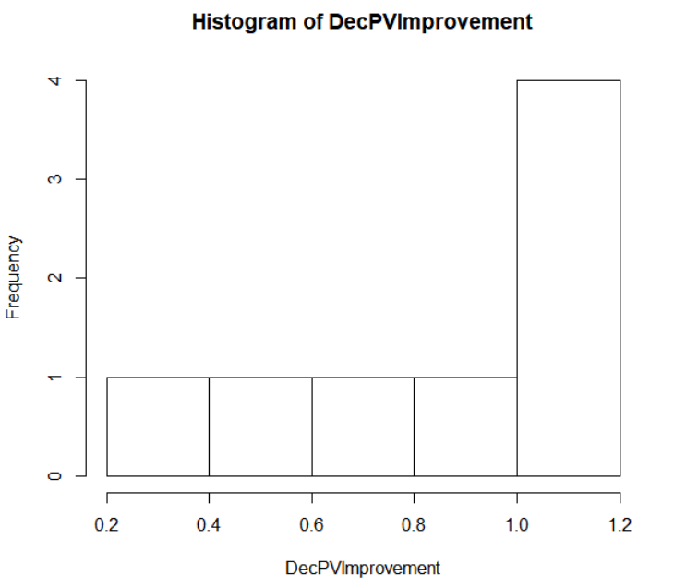

Fig. 147. Histogram of Decathlon pole vault amount improved from high school.

In Figure 148 the numbers tell a similar story with the first quarter starting at 0.6172 meters of improvement and the third quarter at 1.2 meters of improvement. The average high school improvement for the Decathlon pole vault being 0.8858 meters, and the lowest improvement being 0.306 meters and the biggest improvement being 1.2 meters. There are thirty-two high school marks for the Decathlon pole vault that were not found, due to the Decathlon's best high school time not being found.



Fig. 148. Summary of Decathlon pole vault amount improved from high school.

## 4.5.3.7 Decathlon Shot Put

As seen in Figure 149, the shot put improvement from high school by Decathlon with a spike from –0.5 meter to no improvement with small groups lower and higher than that range.

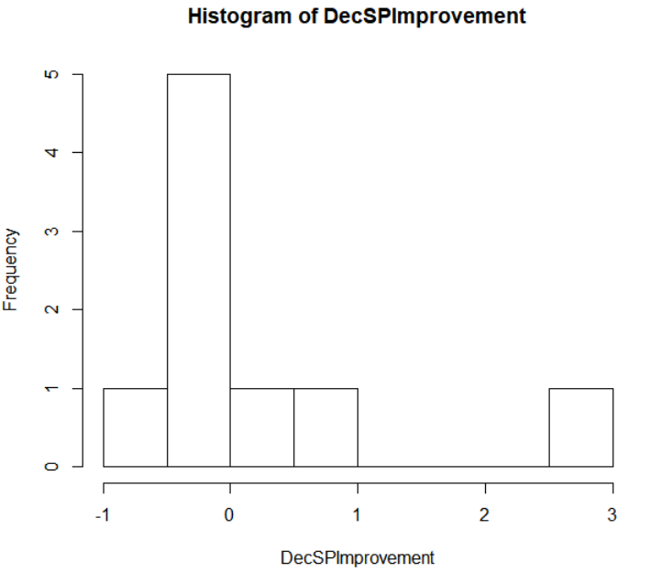

Fig. 149. Histogram of Decathlon shot put amount improved from high school.

In Figure 150 the numbers tell a similar story with the first quarter starting at –0.369 meters of improvement and the third quarter at 0.207 meters of improvement. The average high school improvement for the Decathlon shot put being 0.11.81 meters, and the lowest improvement being -0.67 meters and the biggest improvement being 2.663 meters. There are thirty-one high school marks for the Decathlon shot put that were not found, due to the Decathlon's best high school time not being found.



Fig. 150. Summary of Decathlon shot put amount improved from high school.

## 4.5.3.8 Decathlon Discus

As seen in Figure 151, the discus improvement from high school by Decathlon with a spike from –5 meter to no improvement with small groups higher than that range.

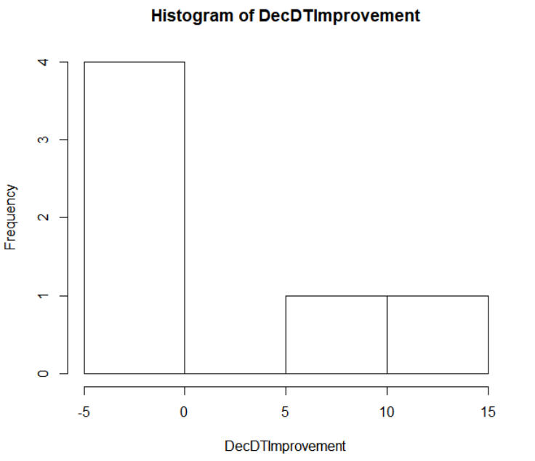

Fig. 151. Histogram of Decathlon discus amount improved from high school.

In Figure 152 the numbers tell a similar story with the first quarter starting at –1.226 meters of improvement and the third quarter at 6.768 meters of improvement. The average high school improvement for the Decathlon discus being 2.74 meters, and the lowest improvement being -3.836 meters and the biggest improvement being 14.529 meters. There are thirty-four high school marks for the Decathlon discus that were not found, due to the Decathlon's best high school time not being found.



Fig. 152. Summary of Decathlon discus amount improved from high school.

## 4.6 Heptathlon

The Heptathlon dataset is looking at the high school events the Heptathlon All-Americans participated in. It contains six out of the seven events, as javelin is uncommon event in high school track and field. The aspects that were analyzed in the Heptathlon dataset are the same as the All-American dataset with looking at the break down of each event’s high school times and marks and looking at the improvement of each event from high school to college. Another aspect that will be analyzed that is different from the All-American dataset and same as the decathlon dataset is looking at how many heptathlon athletes participated in each event in high school, to find which events done in high school are more likely to turn out an All-American Heptathlon athlete.

## 4.6.1 Events of Heptathlon in High School

The number of All-Americans that participated in high school is a good way to find what high school athletes to recruit to become a Heptathlon athlete in college. In Wisconsin high school track and field, athletes are allowed to participate in four events max, with at most three of them either being field or running events. The top four events that are participated in high school by the Heptathlon All-American athletes will be taken into consideration as the type of athletes that will be looked at as potential Heptathlon athletes in college. As in figure 153 the top four events participated in from Heptathlon All-Americans are Long Jump, 200-meter, 100-meter Hurdles, and High Jump. There is not many events that drop off but shot put is the clear event with the least amount.



Fig. 153. Summary of Heptathlon’s All-Americans participation in events from high school.

## 4.6.2 Heptathlon High School Times by Event

This section will break down by event what the high school times and marks of the event are good based off the times and marks of the Heptathlon's. The breakdown of this analysis shows histograms as a visual way to see where an average of the Heptathlon's performed in high school. There are numbers to help better understand the knowledge the histogram is showing.

## 4.6.2.1 Heptathlon 200-meter

As seen in Figure 154, the 200-meter times from high school by Heptathlon with a wide variety of times from 25 seconds to 30 seconds.

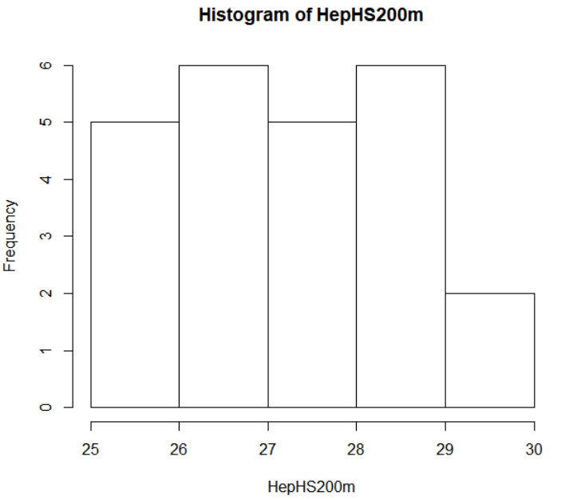

Fig. 154. Histogram of Heptathlon 200-meter times from high school.

In Figure 155 the numbers tell a similar story with the first quarter starting at 26.5 seconds and the third quarter at 28.31 seconds. The average high school time for the Heptathlon 200-meter being 27.33 seconds, and the slowest time being 29.94 seconds and the fastest time being 25.41 seconds. There are sixteen high school times for the Heptathlon 200-meter that were not found, due to the Heptathlon's best high school time not being found.



Fig. 155. Summary of Decathlon 200-meter times from high school.

## 4.6.2.2 Heptathlon 800-meter

As seen in Figure 156, the 800-meter times from high school by Heptathlon with a wide variety of times from 130 seconds to 190 seconds.

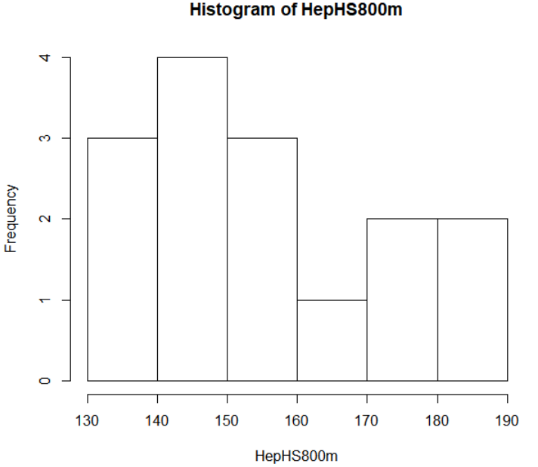

Fig. 156. Histogram of Heptathlon 800-meter times from high school.

In Figure 157 the numbers tell a similar story with the first quarter starting at 141.6 seconds and the third quarter at 171.4 seconds. The average high school time for the Heptathlon 800-meter being 156.1 seconds, and the slowest time being 186.3 seconds and the fastest time being 139.2 seconds. There are twenty-five high school times for the Heptathlon 800-meter that were not found, due to the Heptathlon's best high school time not being found.



Fig. 157. Summary of Decathlon 800-meter times from high school.

## 4.6.2.3 Heptathlon 100-meter Hurdles

As seen in Figure 158, the 100-meter hurdles times from high school by Heptathlon with a couple spikes from 15 seconds to 15.5 seconds and 16 seconds to 16.5 seconds with more faster, slower, and in between the two ranges.

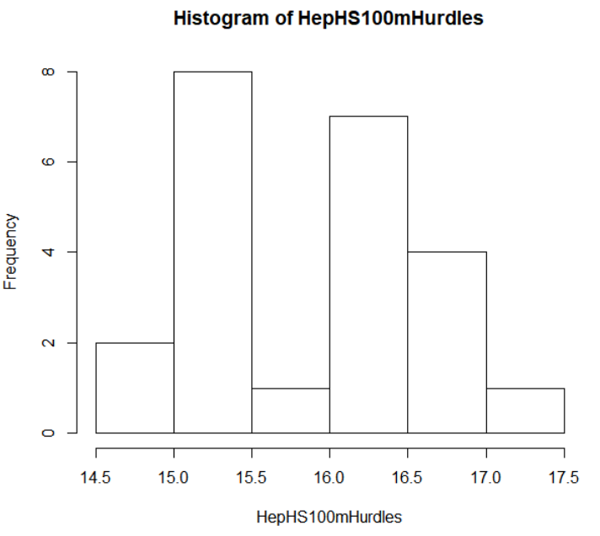

Fig. 158. Histogram of Heptathlon 100-meter hurdles times from high school.

In Figure 159 the numbers tell a similar story with the first quarter starting at 15.26 seconds and the third quarter at 16.44 seconds. The average high school time for the Heptathlon 100-meter hurdles being 15.87 seconds, and the slowest time being 17.21 seconds and the fastest time being 14.79 seconds. There are seventeen high school times for the Heptathlon 100-meter hurdles that were not found, due to the Heptathlon's best high school time not being found.



Fig. 159. Summary of Decathlon 100-meter hurdles times from high school.

## 4.6.2.4 Heptathlon Long Jump

As seen in Figure 160, the long jump marks from high school by Heptathlon with a spike from 5 meters to 5.5 meters, with more farther and shorter than the range.

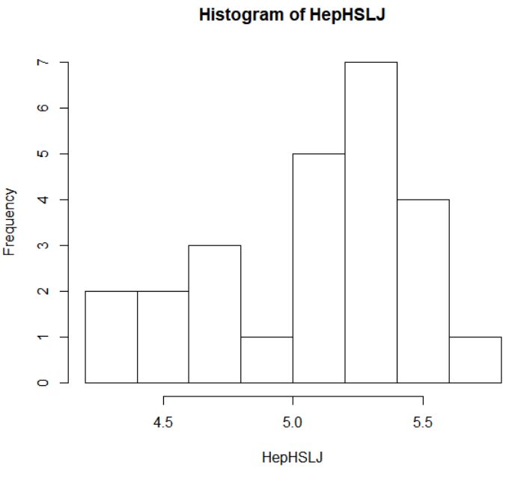

Fig. 160. Histogram of Heptathlon long jump times from high school.

In Figure 161 the numbers tell a similar story with the first quarter starting at 4.718 meters and the third quarter at 5.327 meters. The average high school mark for the Heptathlon long jump being 5.045 meters, and the shortest mark being 4.267 meters and the farthest mark being 5.664 meters. There are fifteen high school times for the Heptathlon long jump that were not found, due to the Heptathlon's best high school time not being found.



Fig. 161. Summary of Decathlon long jump times from high school.

## 4.6.2.5 Heptathlon High Jump

As seen in Figure 162, the long jump marks from high school by Heptathlon with spikes from 1.4 meters to 1.45 meters and 1.5 meters to 1.55 meters, with more farther, shorter, and in between that range.

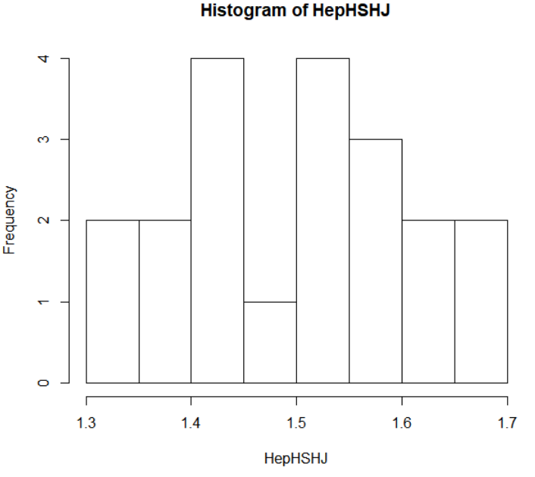

Fig. 162. Histogram of Heptathlon high jump times from high school.

In Figure 163 the numbers tell a similar story with the first quarter starting at 1.409 meters and the third quarter at 1.581 meters. The average high school mark for the Heptathlon high jump being 1.506 meters, and the shortest mark being 1.32 meters and the highest mark being 1.676 meters. There are twenty high school times for the Heptathlon high jump that were not found, due to the Heptathlon's best high school time not being found.



Fig. 163. Summary of Decathlon high jump times from high school.

## 4.6.2.6 Heptathlon Shot Put

As seen in Figure 164, the shot put marks from high school by Heptathlon gradually build as the distance increases.

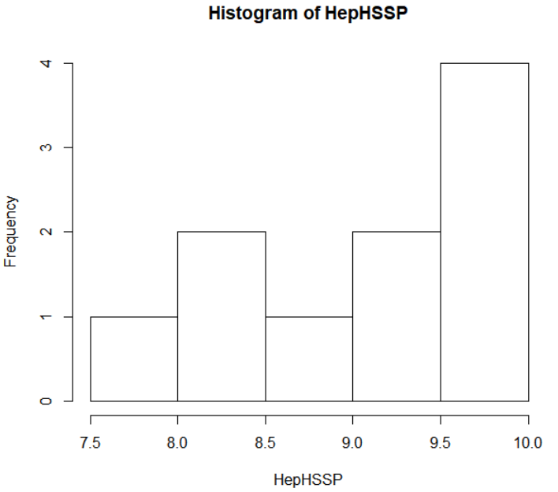

Fig. 164. Histogram of Heptathlon shot put times from high school.

In Figure 165 the numbers tell a similar story with the first quarter starting at 8.46 meters and the third quarter at 9.823 meters. The average high school mark for the Heptathlon shot put being 9.119 meters, and the shortest mark being 7.924 meters and the farthest mark being 9.994 meters. There are thirty high school times for the Heptathlon high jump that were not found, due to the Heptathlon's best high school time not being found.



Fig. 165. Summary of Decathlon shot put times from high school.

## 4.6.3 Heptathlon High School PR vs College PR

Another aspect to look at for the Heptathlons is the amount they improved from their high school PR. Here there will be a breakdown between the college PR and the high school PR, looking at the average improvement in college to understand how much athletes might improve in each event.

## 4.6.3.1 Heptathlon 200-meter

As seen in Figure 166, the 200-meter improvement from high school by Heptathlon have a spike of improvement from 0.5 second to 1 second, with a variety higher and lower than that range.

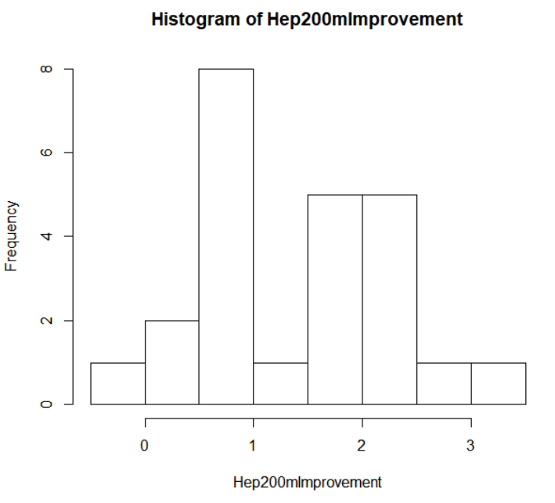

Fig. 166. Histogram of Heptathlon 200-meter amount improved from high school.

In Figure 167 the numbers tell a similar story with the first quarter starting at 0.59 seconds of improvement and the third quarter at 2.328 seconds of improvement. The average high school improvement for the Heptathlon 200-meter being 1.399 seconds, and the lowest improvement being -0.27 seconds and the biggest improvement being 3.14 seconds. There are sixteen high school times for the Heptathlon 200-meter that were not found, due to the Heptathlon's best high school time not being found.



Fig. 167. Summary of Heptathlon 200-meter amount improved from high school.

## 4.6.3.2 Heptathlon 800-meter

As seen in Figure 168, the 800-meter improvement from high school by Heptathlon majority of improvement from no improvement to 10 second, with a smaller amount higher than that range.

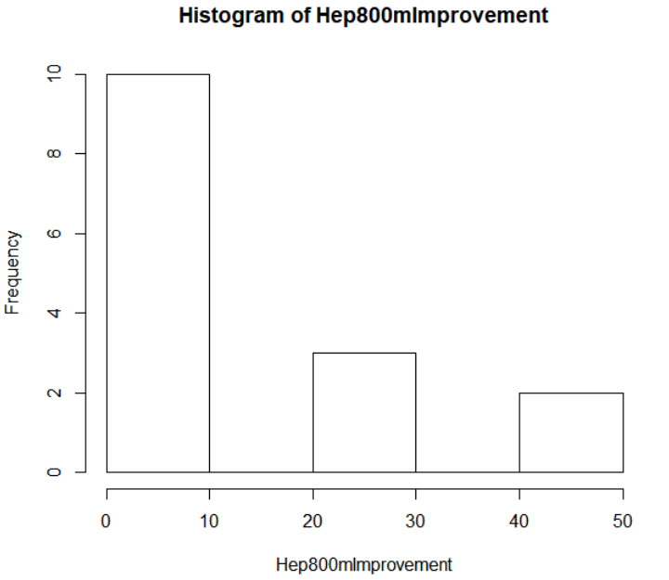

Fig. 168. Histogram of Heptathlon 800-meter amount improved from high school.

In Figure 169 the numbers have a vast variety with the first quarter starting at 3.15 seconds of improvement and the third quarter at 25 seconds of improvement. The average high school improvement for the Heptathlon 800-meter being 13.67 seconds, and the lowest improvement being 1.1 seconds and the biggest improvement being 41.3 seconds. There are twenty-five high school times for the Heptathlon 800-meter that were not found, due to the Heptathlon's best high school time not being found.



Fig. 169. Summary of Heptathlon 800-meter amount improved from high school.

## 4.6.3.3 Heptathlon 100-meter Hurdles

As seen in Figure 170, the 100-meter hurdles improvement from high school by Heptathlon with an increase in the amount as the improvement increases.

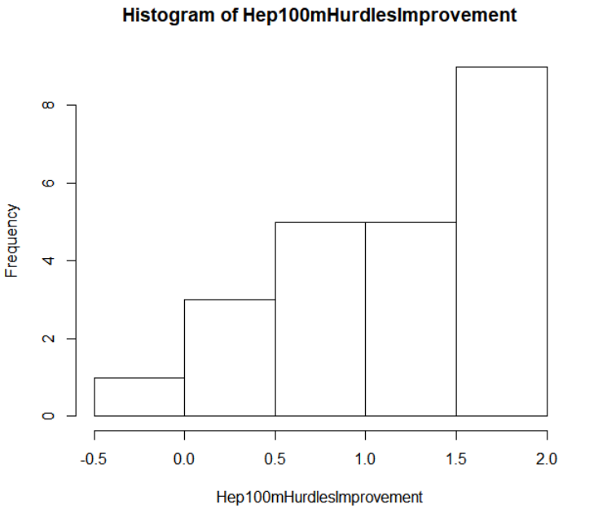

Fig. 170. Histogram of Heptathlon 100-meter hurdles amount improved from high school.

In Figure 171 the numbers tell a similar story with the first quarter starting at 0.83 seconds of improvement and the third quarter at 1.725 seconds of improvement. The average high school improvement for the Heptathlon 100-meter hurdles being 1.196 seconds, and the lowest improvement being -0.23 seconds and the biggest improvement being 1.99 seconds. There are seventeen high school times for the Heptathlon 100-meter hurdles that were not found, due to the Heptathlon's best high school time not being found.



Fig. 171. Summary of Heptathlon 100-meter hurdles amount improved from high school.

## 4.6.3.4 Heptathlon Long Jump

As seen in Figure 172, the long jump improvement from high school by Heptathlon with a spike from 0.2 meters to 0.4 meters, with more groups higher and lower than the range.

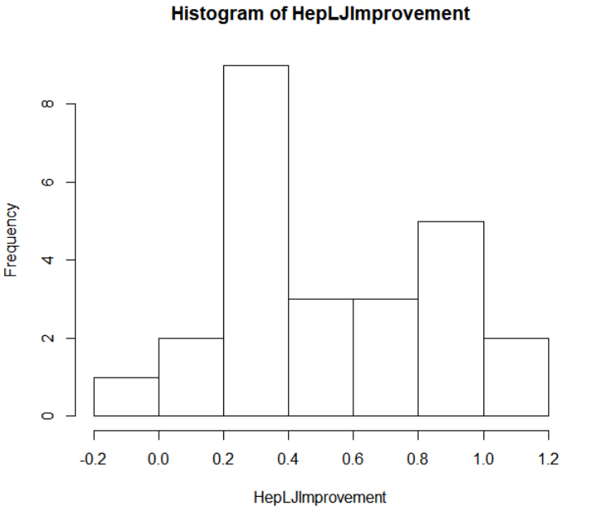

Fig. 172. Histogram of Heptathlon long jump amount improved from high school.

In Figure 173 the numbers tell a similar story with the first quarter starting at 0.309 meters of improvement and the third quarter at 0.827 meters of improvement. The average high school improvement for the Heptathlon long jump being 0.5414 seconds, and the lowest improvement being -0.065 seconds and the biggest improvement being 1.177 seconds. There are fifteen high school times for the Heptathlon long jump that were not found, due to the Heptathlon's best high school time not being found.



Fig. 173. Summary of Heptathlon long jump amount improved from high school.

## 4.6.3.5 Heptathlon High Jump

As seen in Figure 174, the high jump improvement from high school by Heptathlon with a variety of improvements from no improvement to 0.25 meters.

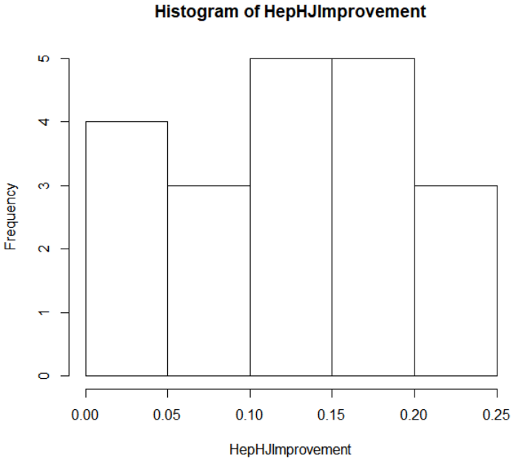

Fig. 174. Histogram of Heptathlon high jump amount improved from high school.

In Figure 175 the numbers tell a similar story with the first quarter starting at 0.062 meters of improvement and the third quarter at 0.171 meters of improvement. The average high school improvement for the Heptathlon high jump being 0.1177 meters, and the lowest improvement being 0 meters and the biggest improvement being 0.22 meters. There are twenty high school times for the Heptathlon high jump that were not found, due to the Heptathlon's best high school time not being found.



Fig. 175. Summary of Heptathlon high jump amount improved from high school.

## 4.6.3.5 Heptathlon High Jump

As seen in Figure 174, the high jump improvement from high school by Heptathlon with a variety of improvements from no improvement to 0.25 meters.



Fig. 174. Histogram of Heptathlon high jump amount improved from high school.

In Figure 175 the numbers tell a similar story with the first quarter starting at 0.062 meters of improvement and the third quarter at 0.171 meters of improvement. The average high school improvement for the Heptathlon high jump being 0.1177 meters, and the lowest improvement being 0 meters and the biggest improvement being 0.22 meters. There are twenty high school times for the Heptathlon high jump that were not found, due to the Heptathlon's best high school time not being found.



Fig. 175. Summary of Heptathlon high jump amount improved from high school.

## 4.6.3.6 Heptathlon Shot Put

As seen in Figure 176, the shot put improvement from high school by Heptathlon with a variety of improvements, with a spike from 2 meters to 2.5 meters.

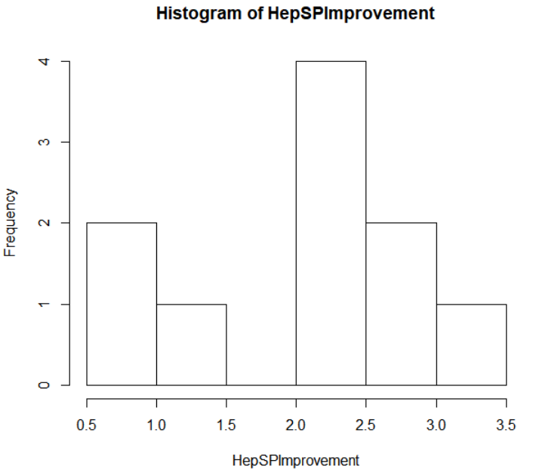

Fig. 176. Histogram of Heptathlon shot put amount improved from high school.

In Figure 177 the numbers tell a similar story with the first quarter starting at 1.591 meters of improvement and the third quarter at 2.63 meters of improvement. The average high school improvement for the Heptathlon shot put being 2.01 meters, and the lowest improvement being 0.517 meters and the biggest improvement being 3.352 meters. There are thirty high school times for the Heptathlon shot put that were not found, due to the Heptathlon's best high school time not being found.



Fig. 177. Summary of Heptathlon shot put amount improved from high school.

# 5 Acknowledgments

I would like to thank Andrew Eggerth the head coach at UWRF for bringing this project to my attention, and to sit down with me and work out the details of the project. From the information I should collect about the All-Americans to where I could look to find the information needed to complete this project. Mr. Eggerth also went through what events should be in the project, which events shouldn’t, and which events could be compared to other high school events. I’m thankful to give back to the team as I am an Alum of the team, and I am thankful for the experience gained by completing this project.

# 6 Conclusion

The All-American project brought a lot of insight into the where the athletes are from, what times and marks are good for each event based off the high school marks, and the improvement of the athletes from high school to college by event. Wisconsin is the state that has had the most All-Americans since 2016 across all three datasets, Decathlon, Heptathlon, and the rest of the All-Americans. There are other states and regions that had a lot of All-Americans and would be good spots to recruit track and field athletes for Division III. Each event showed the outliers from comparing the top two times and marks for each All-American from highs school, but majority of the athletes fell close together. The improvements from event to event varied, with throwing events showing a more variation, with more people not improving from high school but also improving by great amounts. The running events showed a more consistent improvement compared to other events but still consisted of some outliers. The Decathlon and Heptathlon datasets investigated similar things but also the added measure of looking to see how many All-Americans participated in each event in high school that was also a part of the multi. The Decathlon found that the top four events that were competed in from high school were High Jump,110-meter Hurdles, Long Jump, and 400-meter. The top four events competed in for the Heptathlon All-Americans in high school were, Long Jump, 200-meter, 100-meter Hurdles, and High Jump. The smaller number of data points made for more variations for the breakdown of each event. All the information for these datasets were collected by hand, using TFRRS.org as the way to gain the college information needed for the project and the use of Athletic.net was the way to gain the high school information, as well as the information of where the All-American is from. This project is intended to give the UWRF an edge in recruiting for the coming years to help build the program to new heights.

**References**

1. [https://www.athletic.net](https://www.athletic.net/)
2. <https://www.tfrrs.org/>
3. <https://ny.milesplit.com/calc>
4. <http://www.phy.ilstu.edu/pte/302content/student_lab_hdbk/How_Many_Data_Points.pdf>